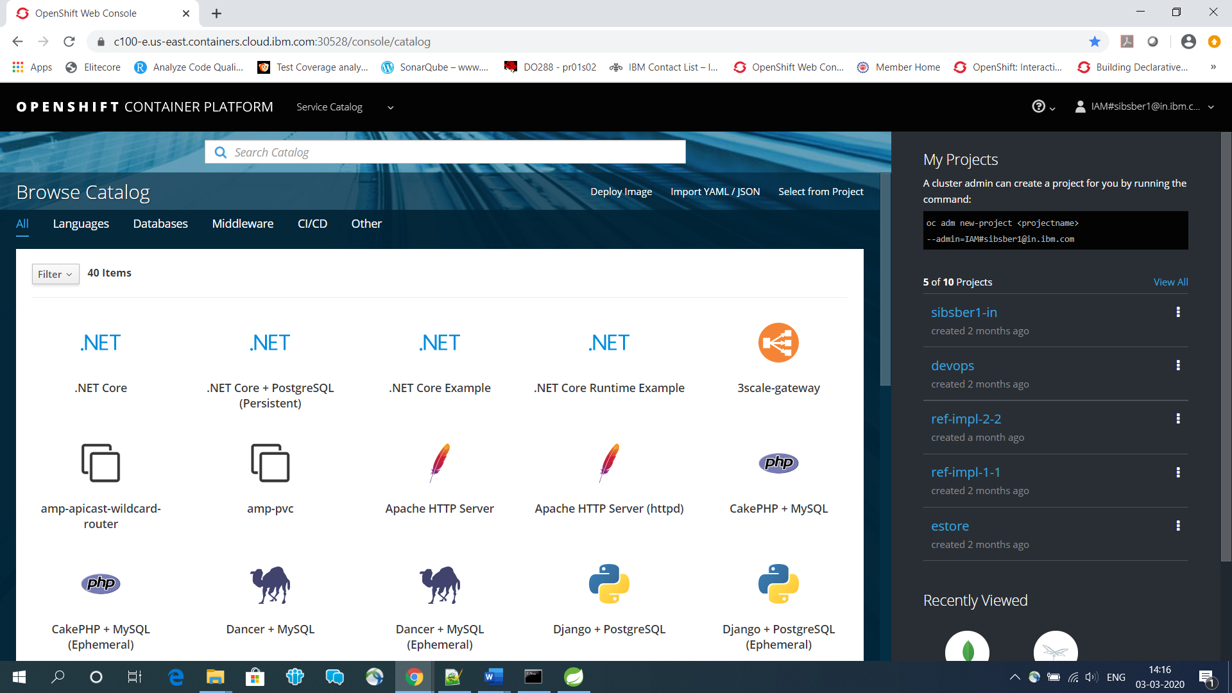

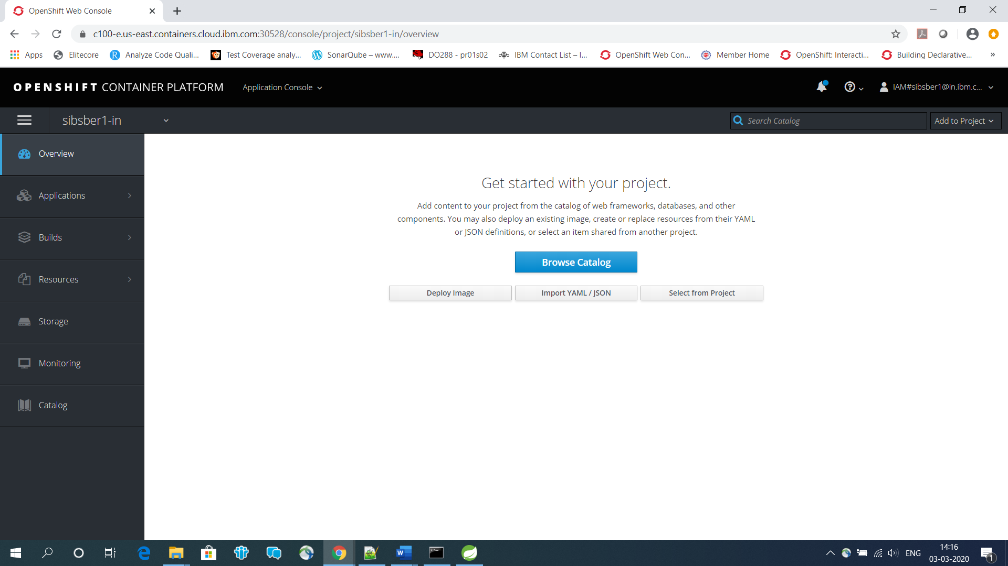

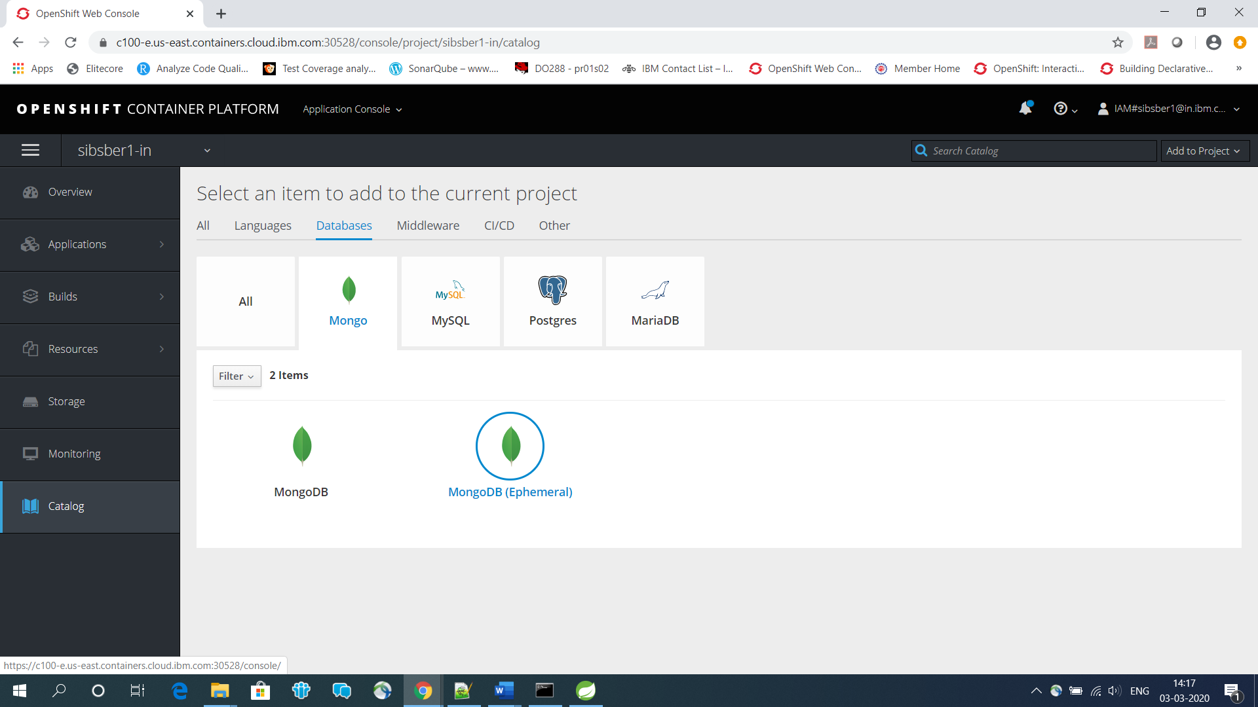

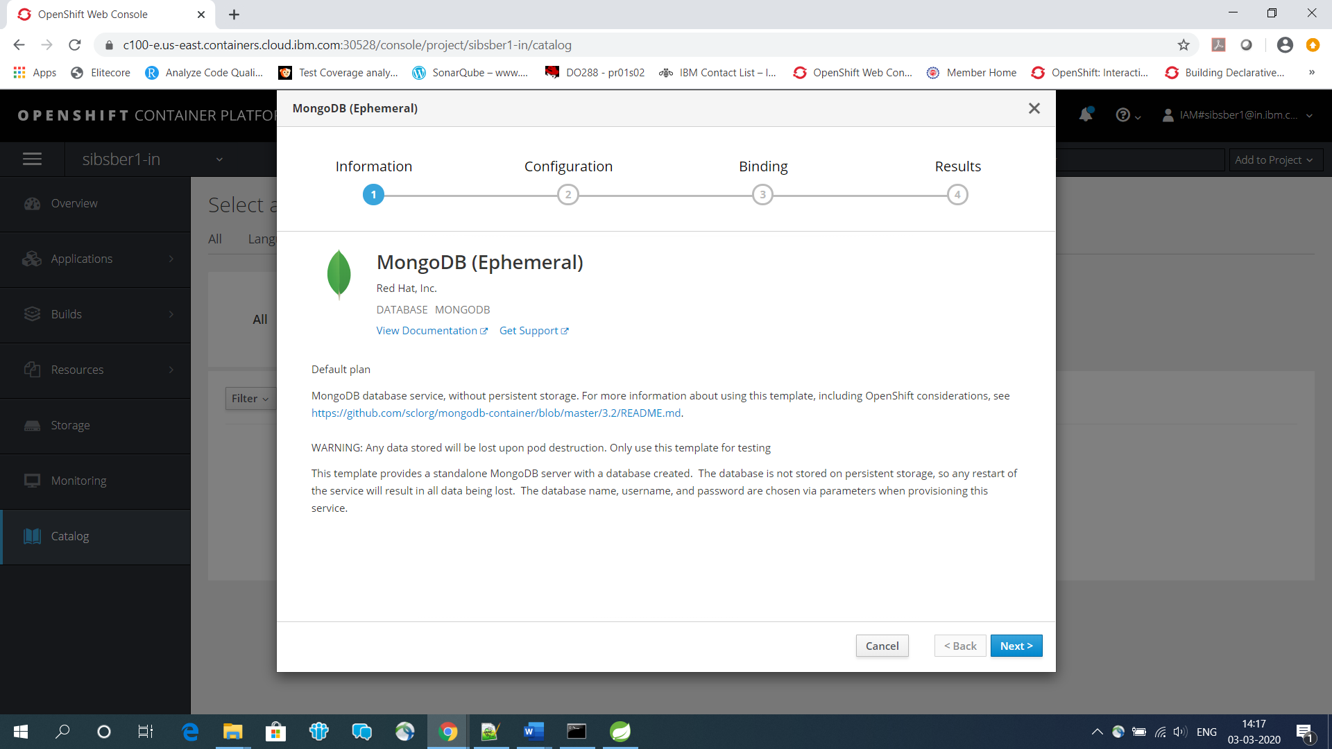

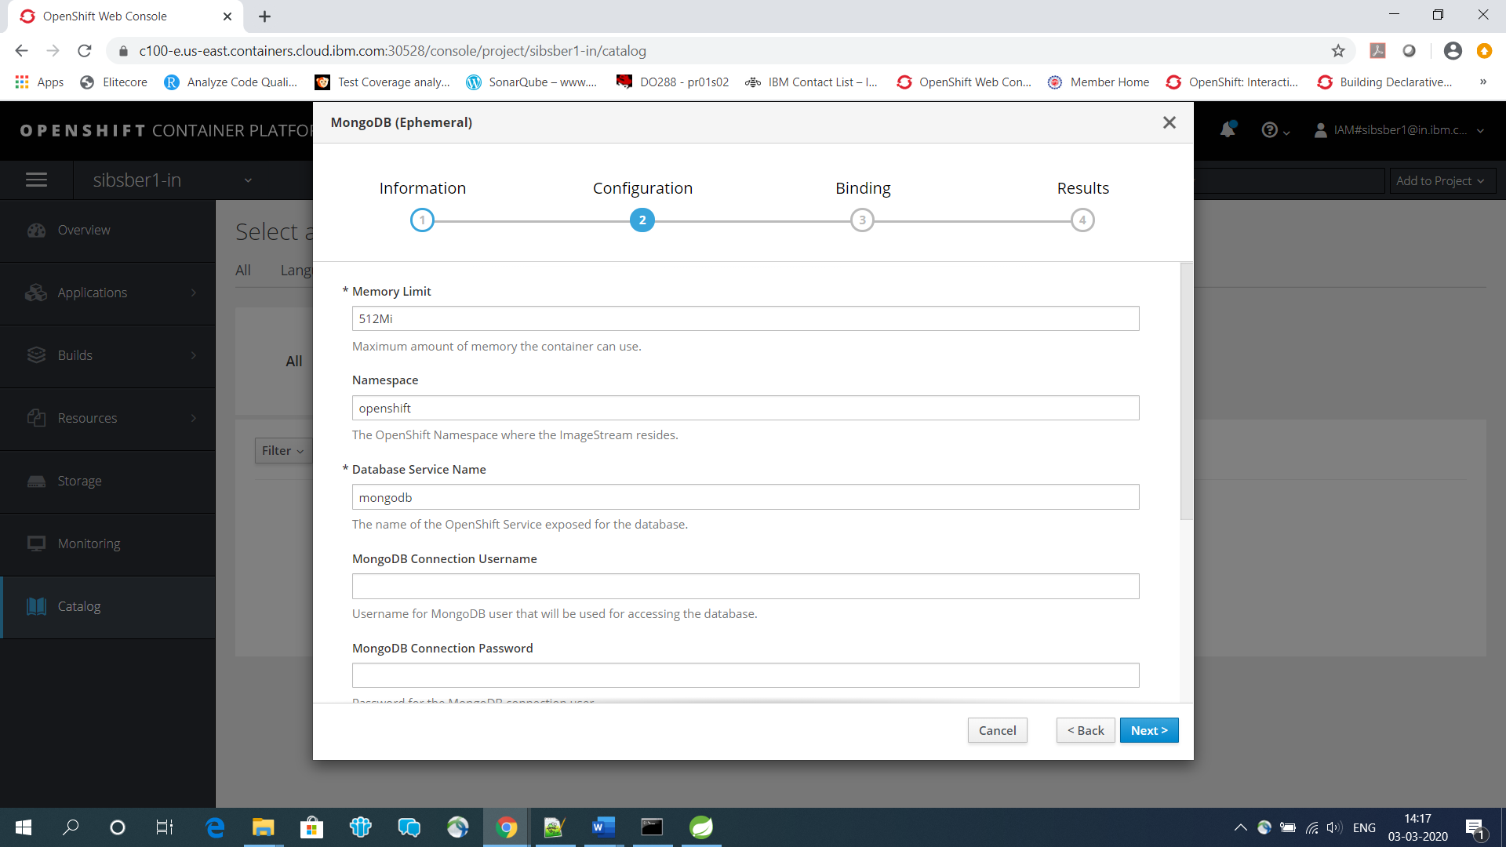

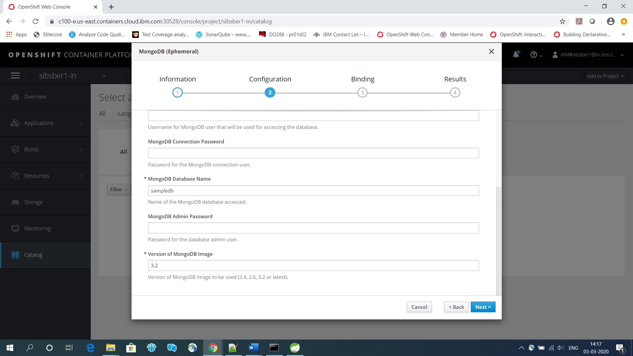

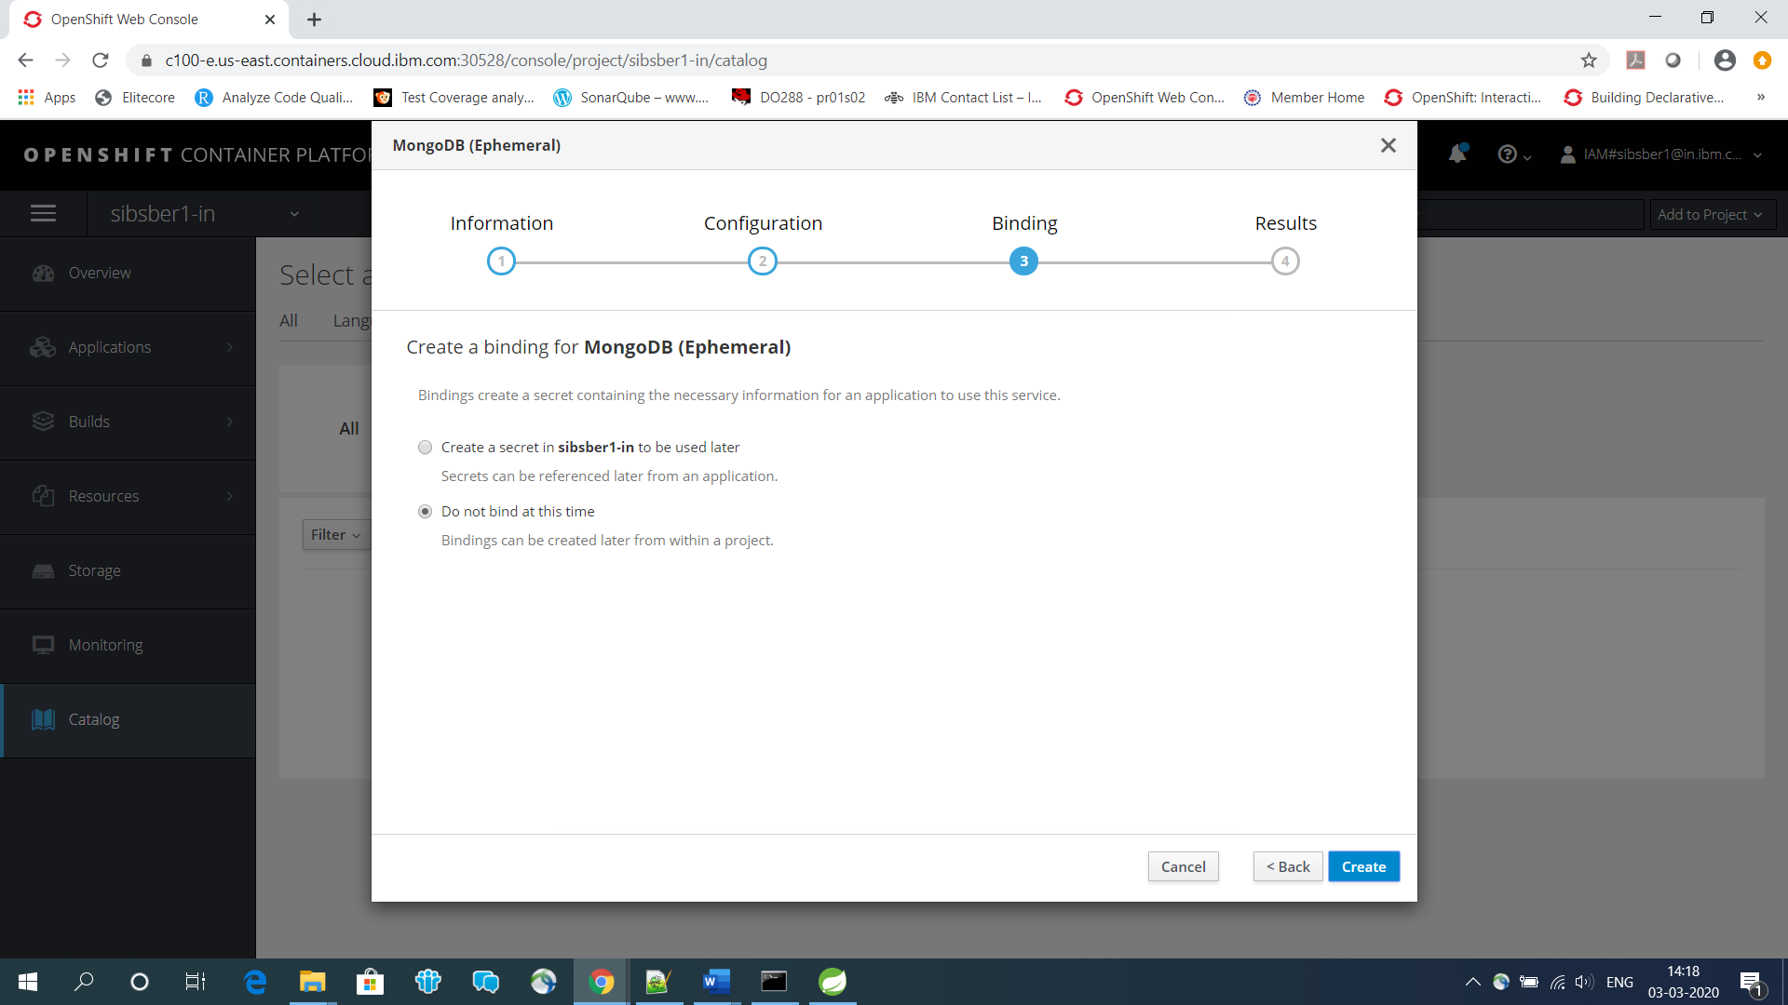

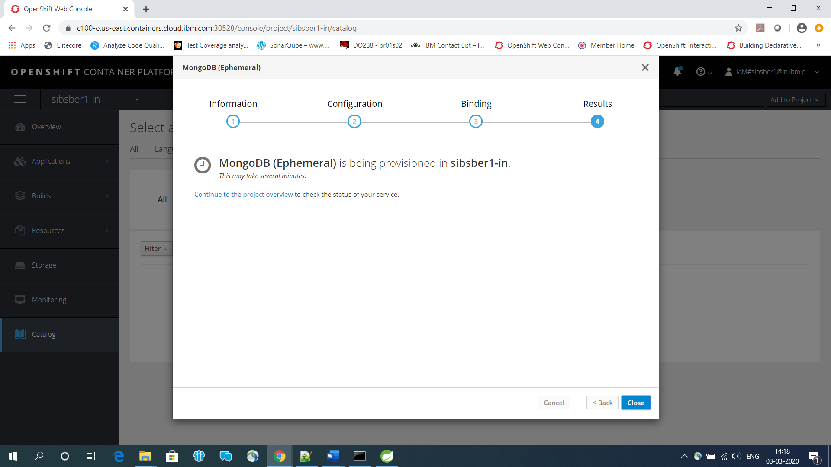

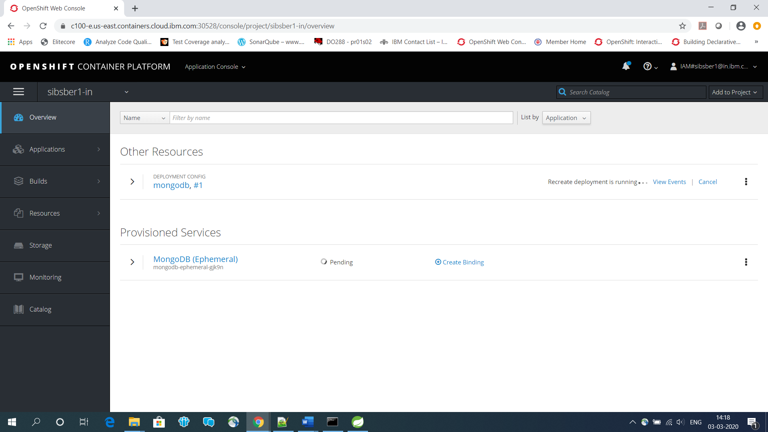

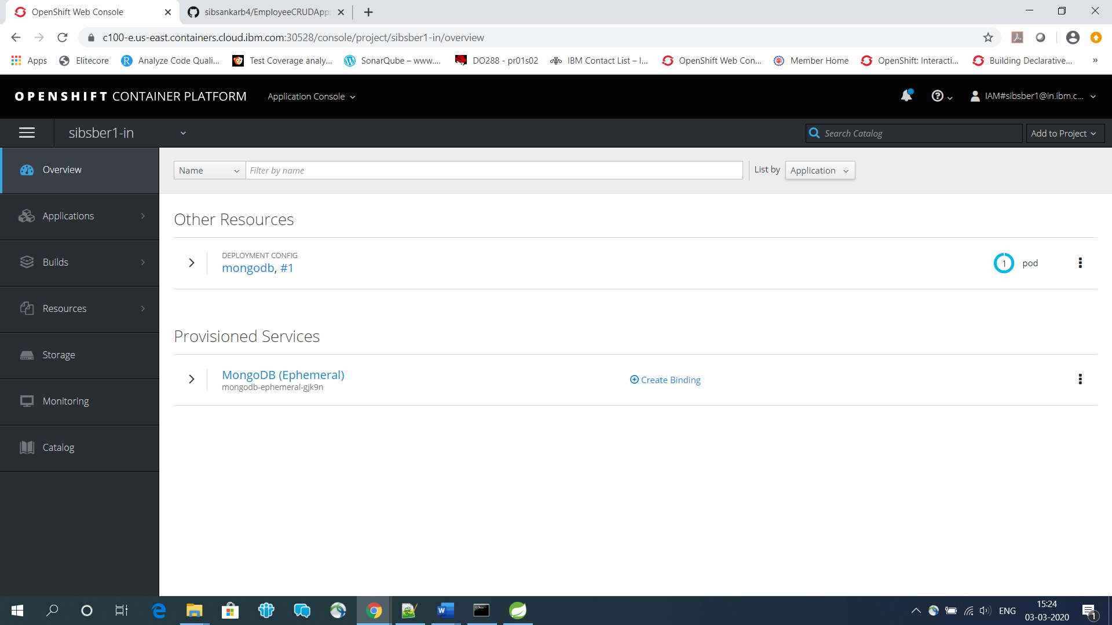

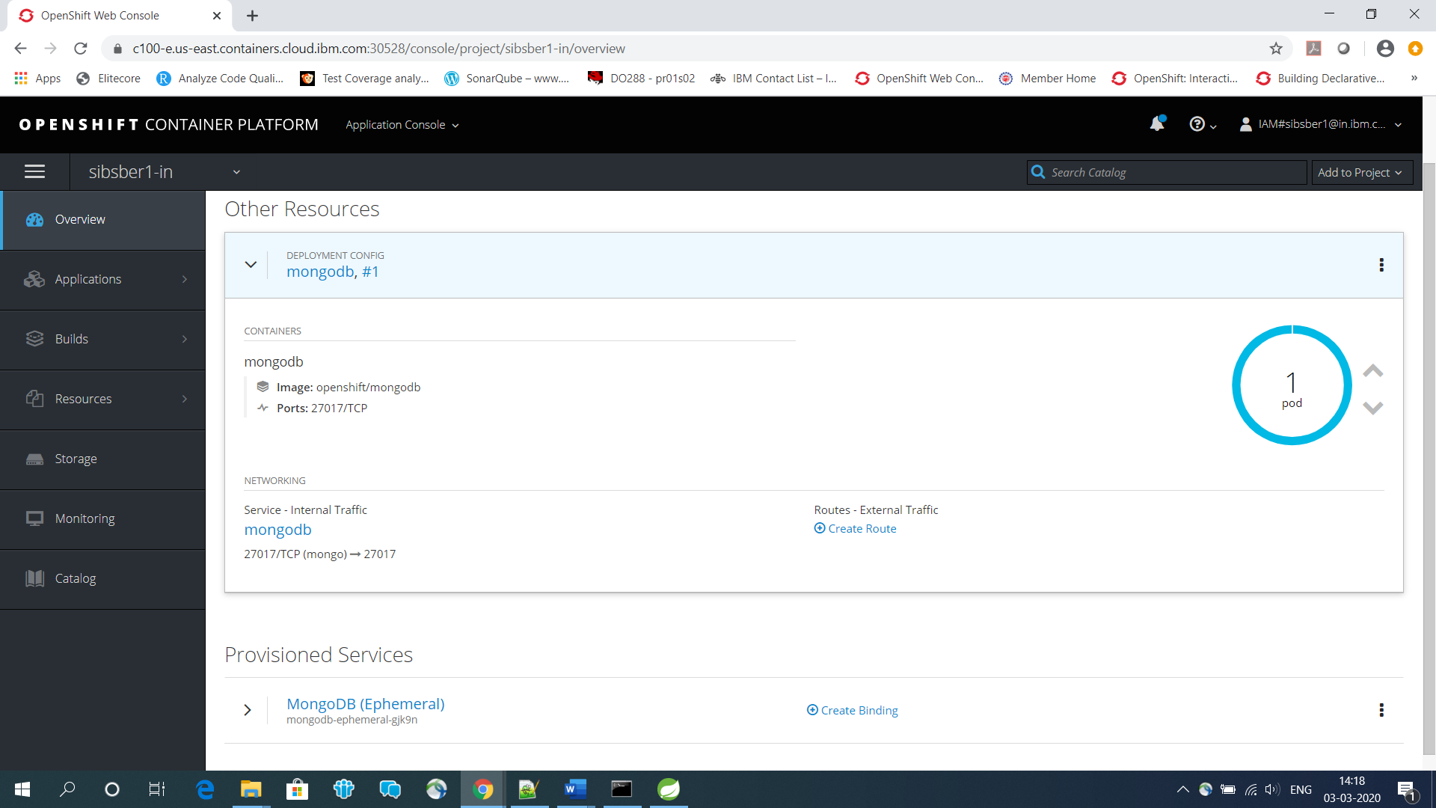

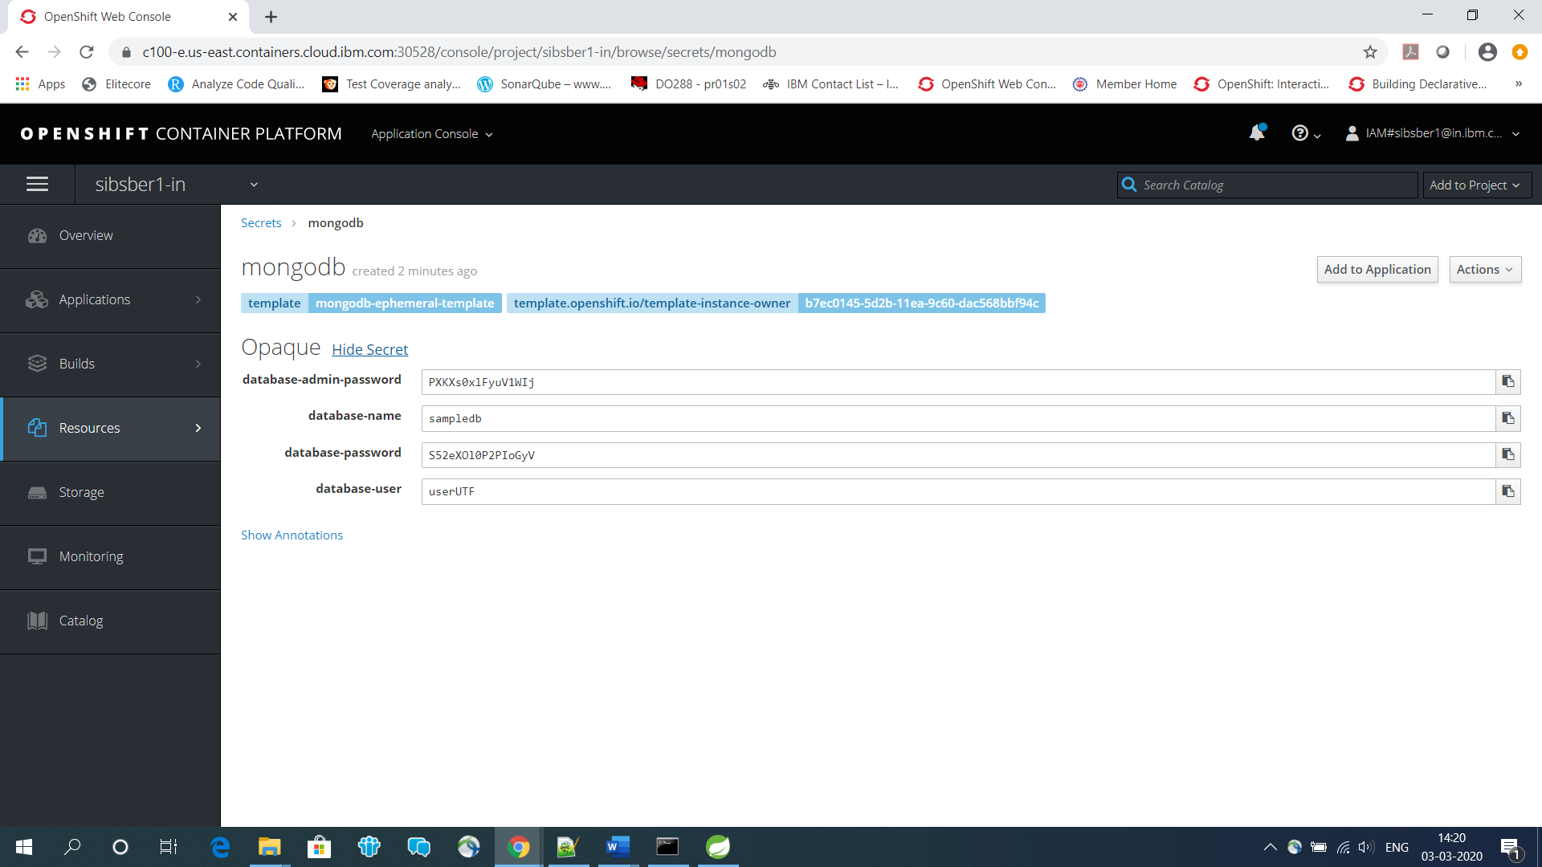

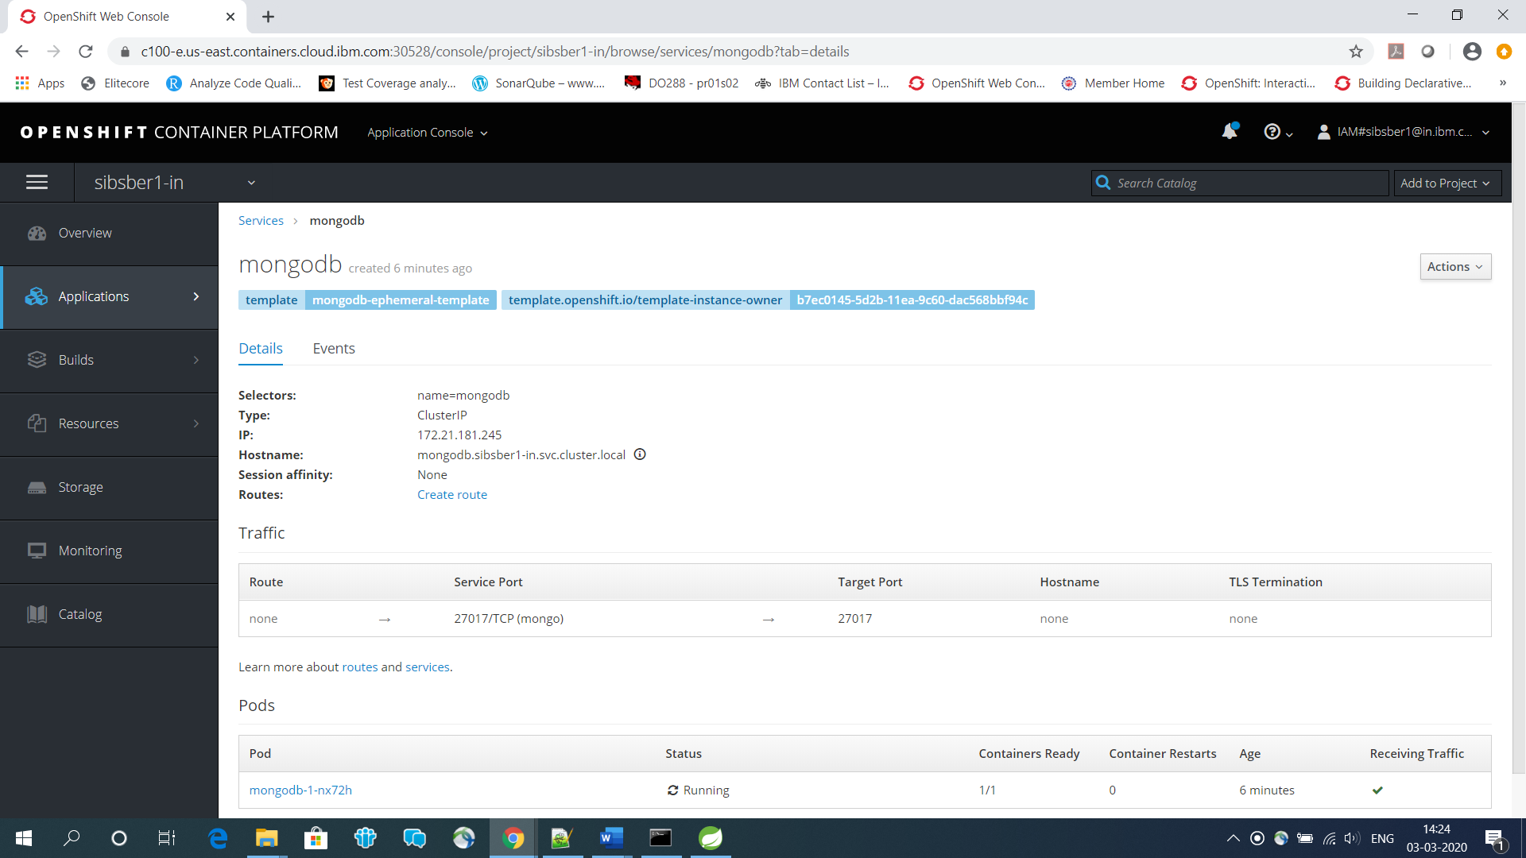

https://github.com/sibsankarb4/EmployeeCRUDApp.git

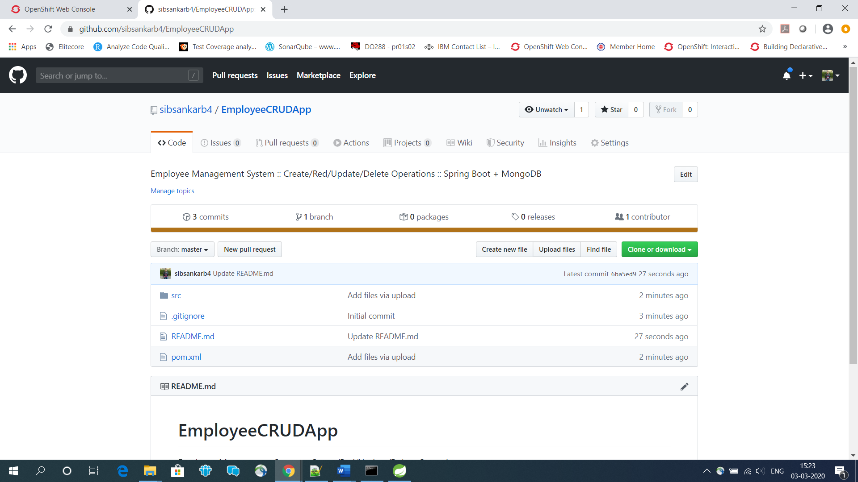

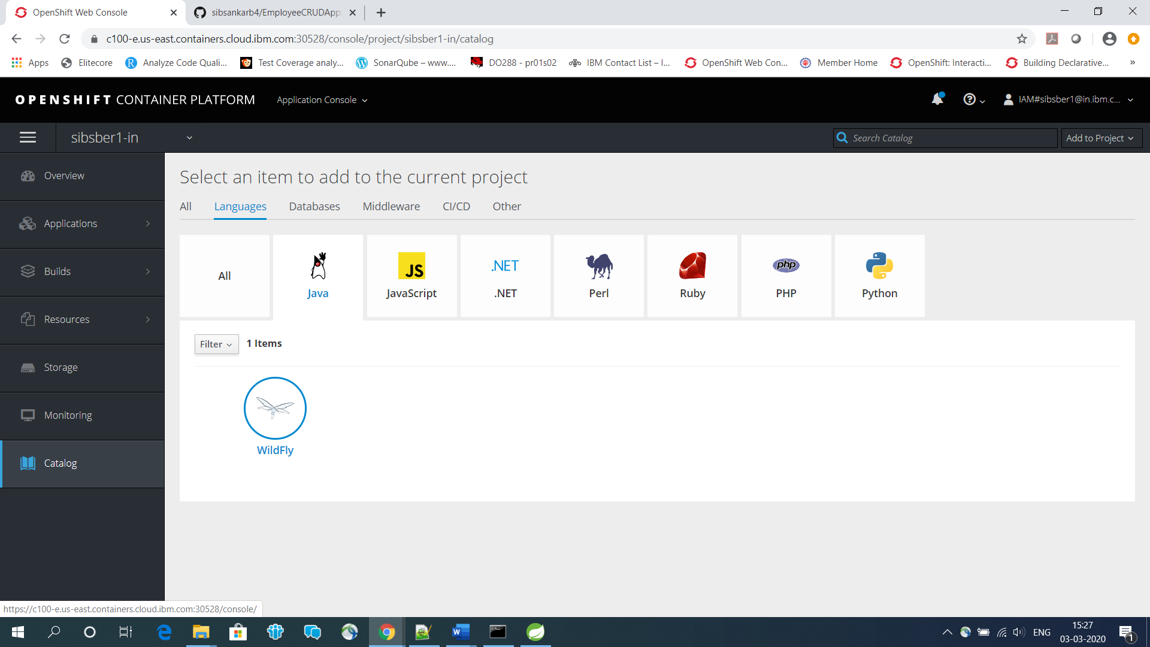

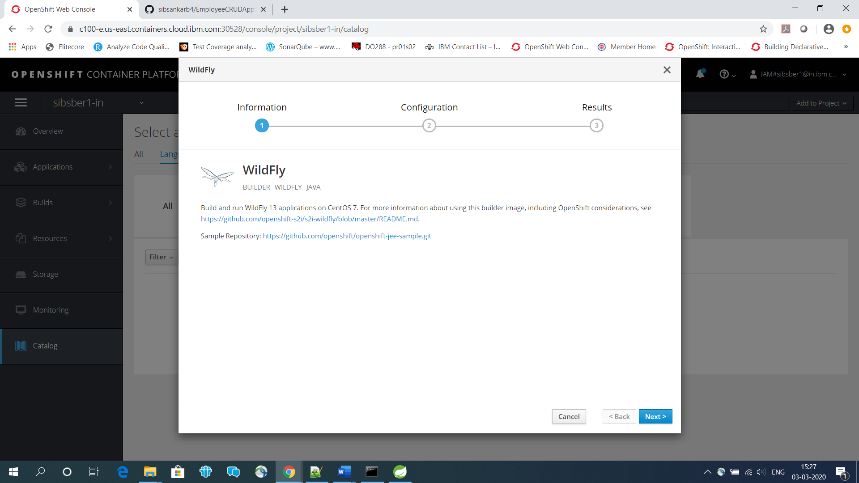

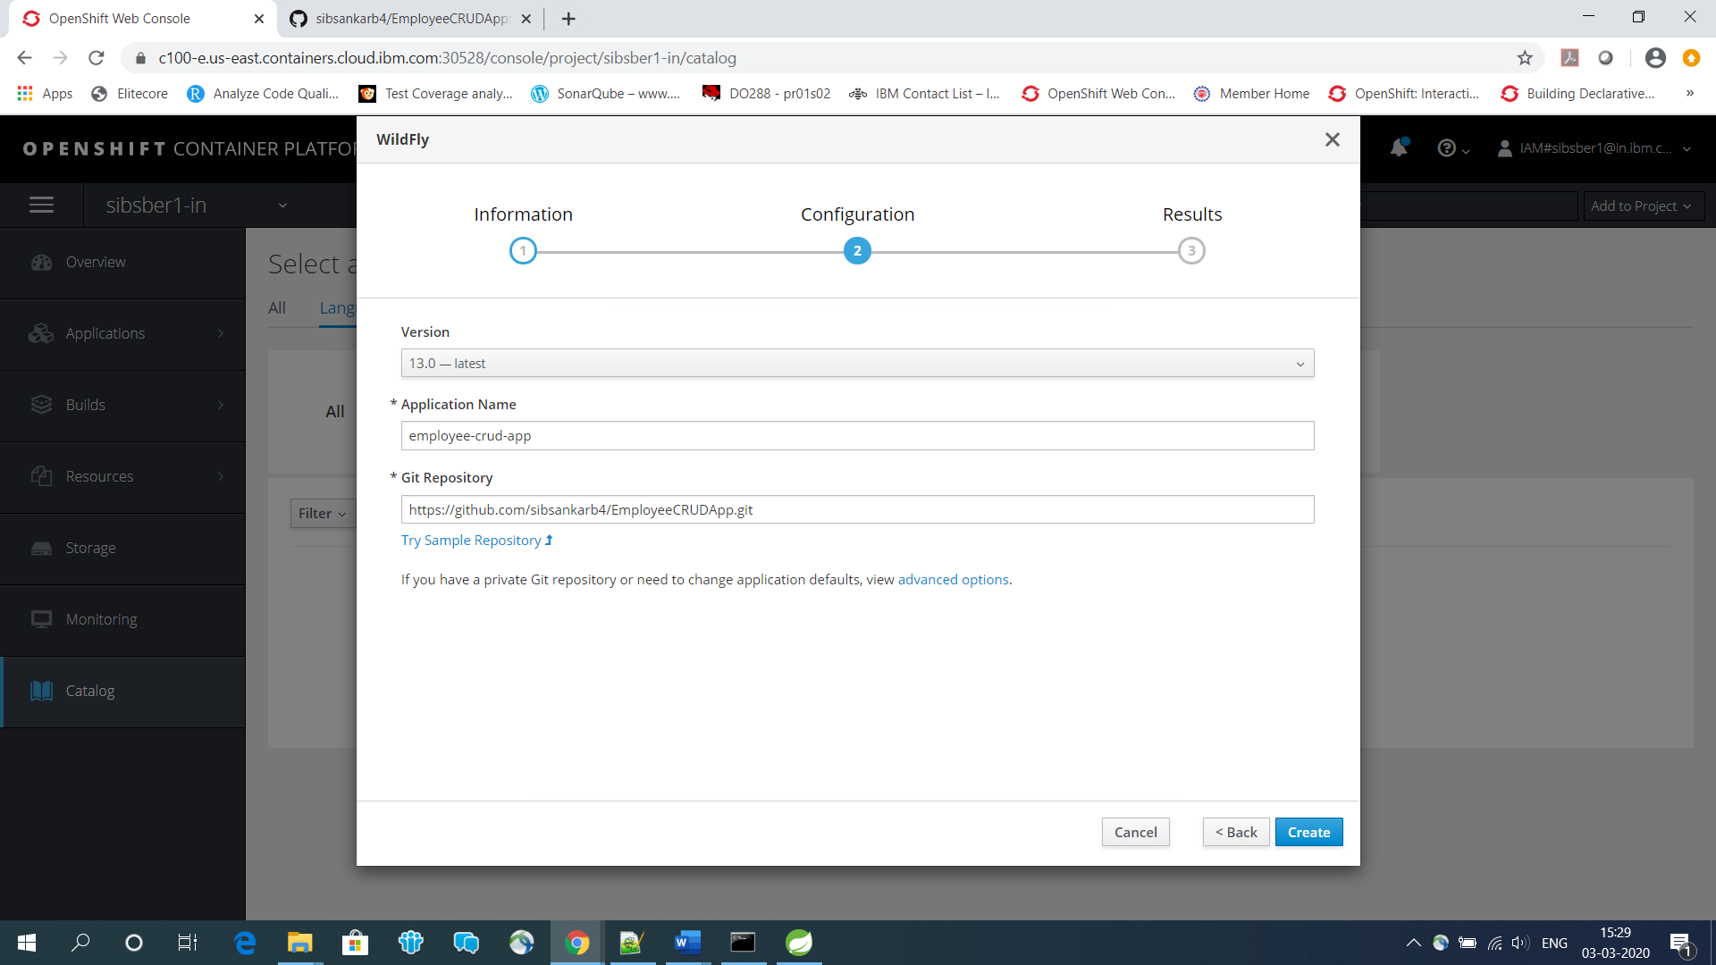

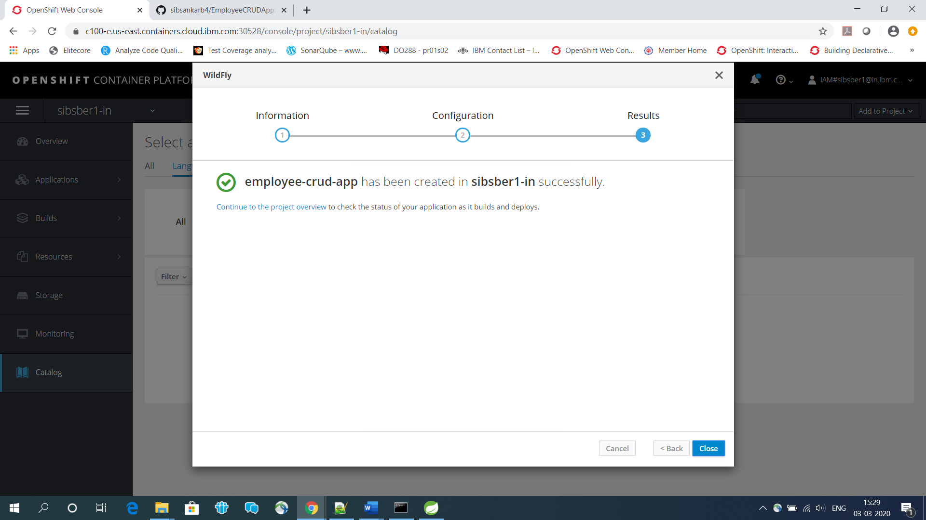

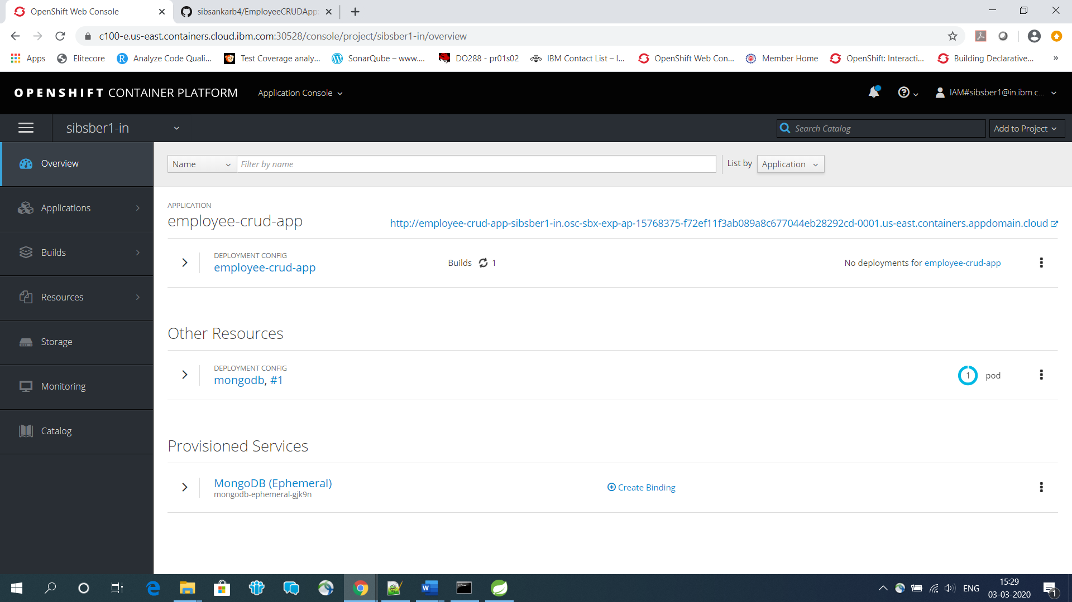

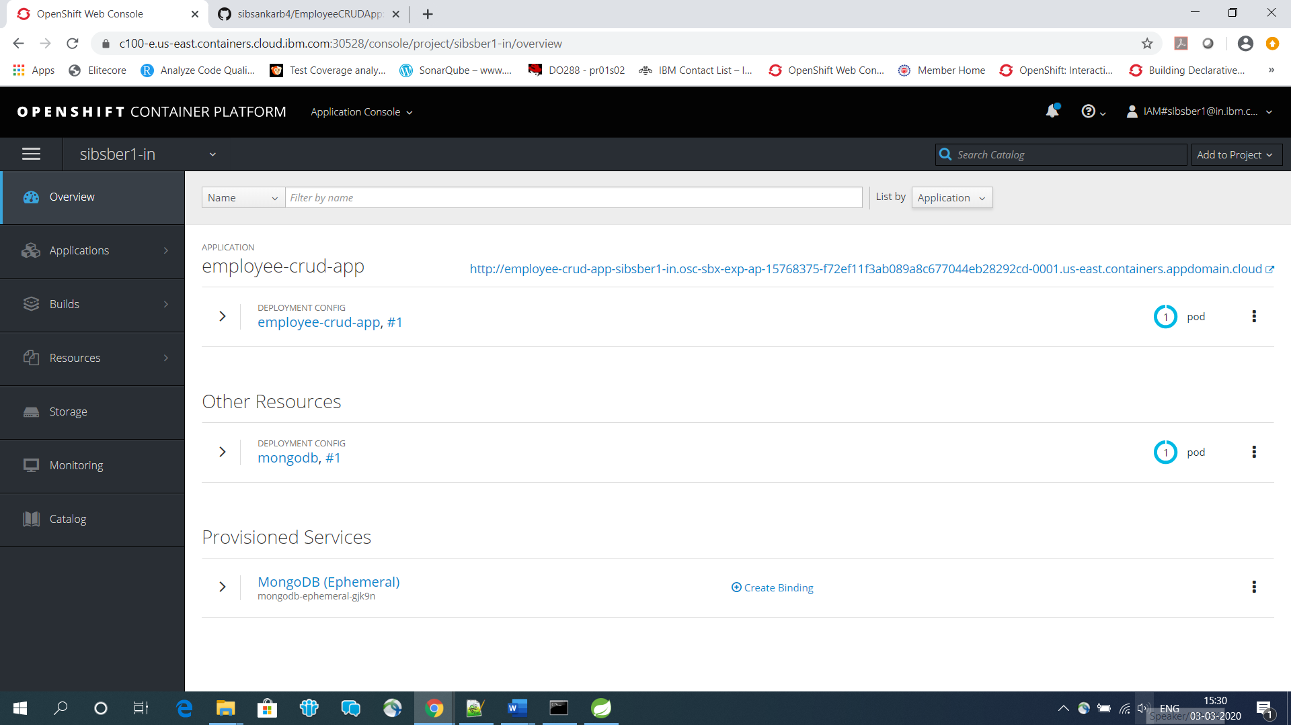

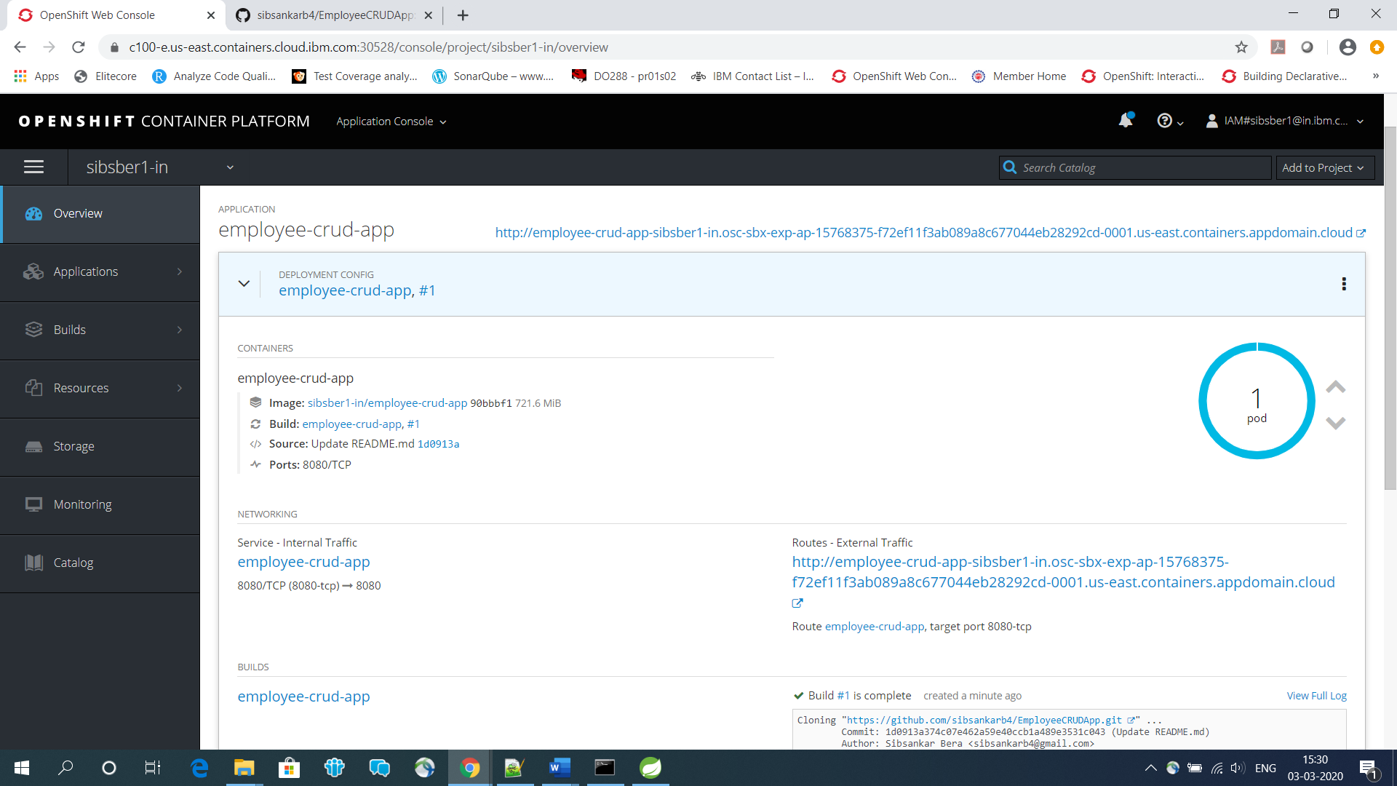

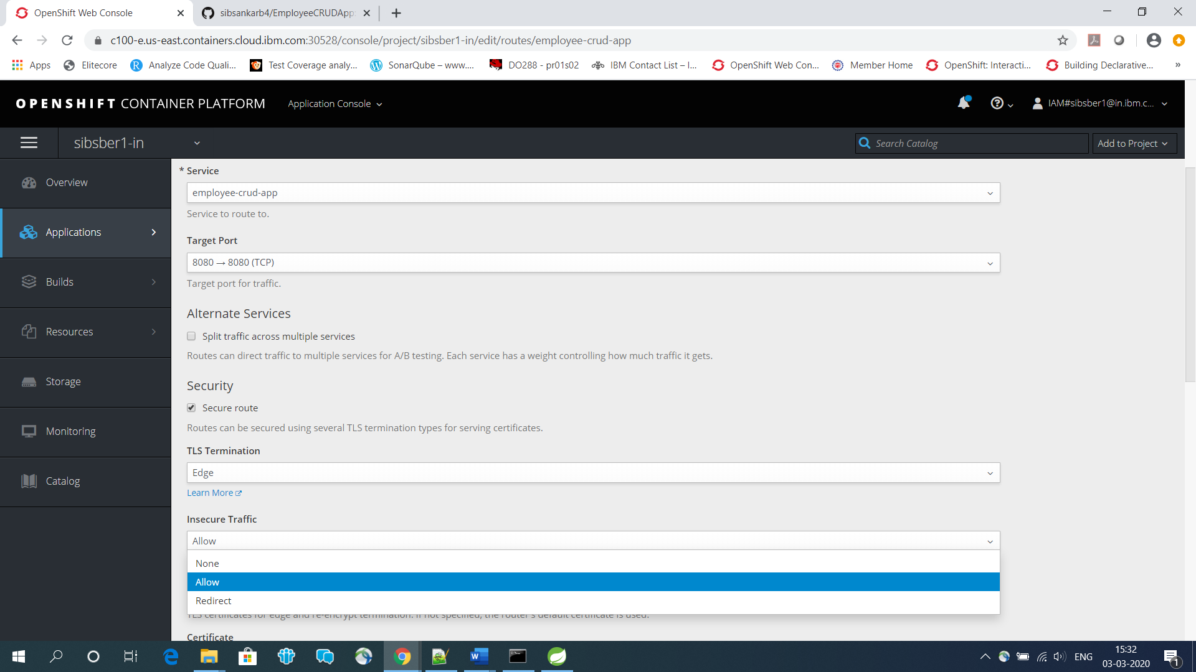

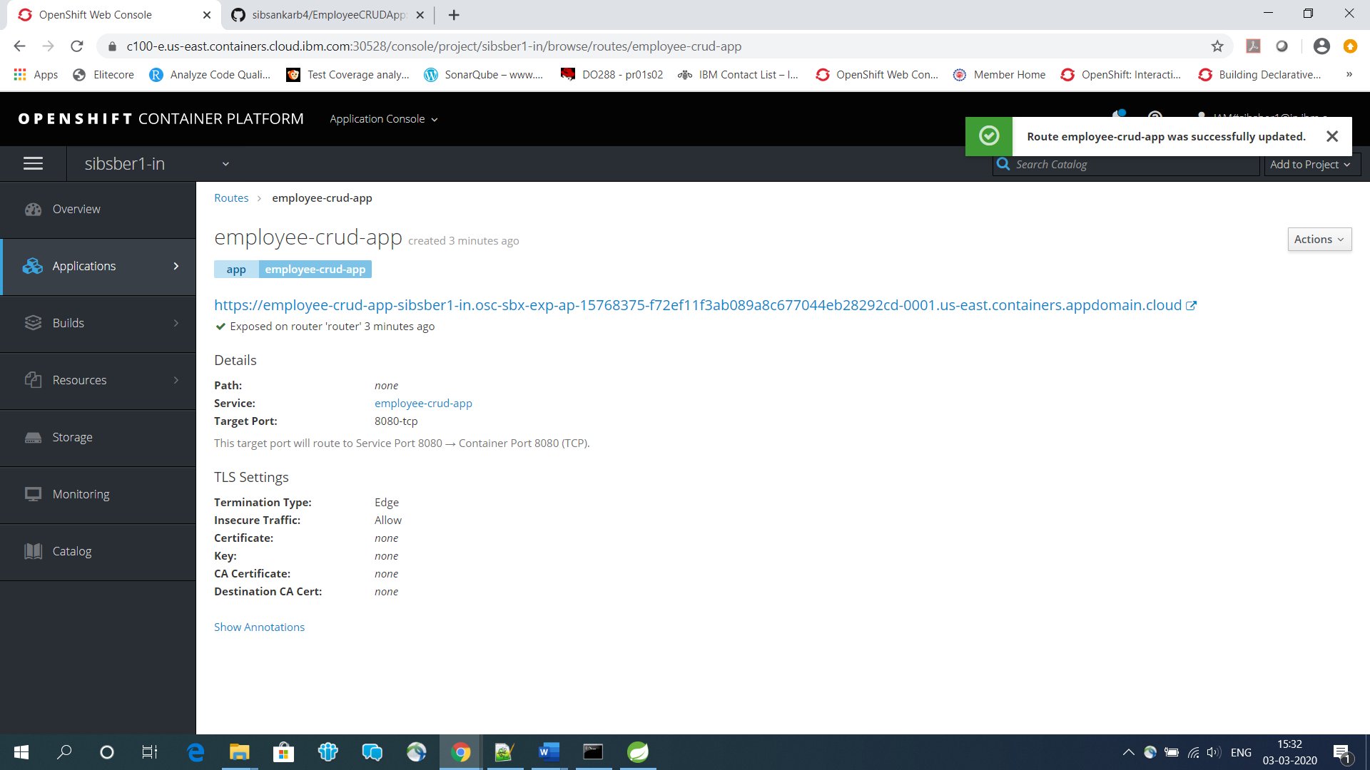

<https://employee-crud-app-sibsber1-in.osc-sbx-exp-ap-15768375-f72ef11f3ab089a8c677044eb28292cd-0001.us-east.containers.appdomain.cloud/>

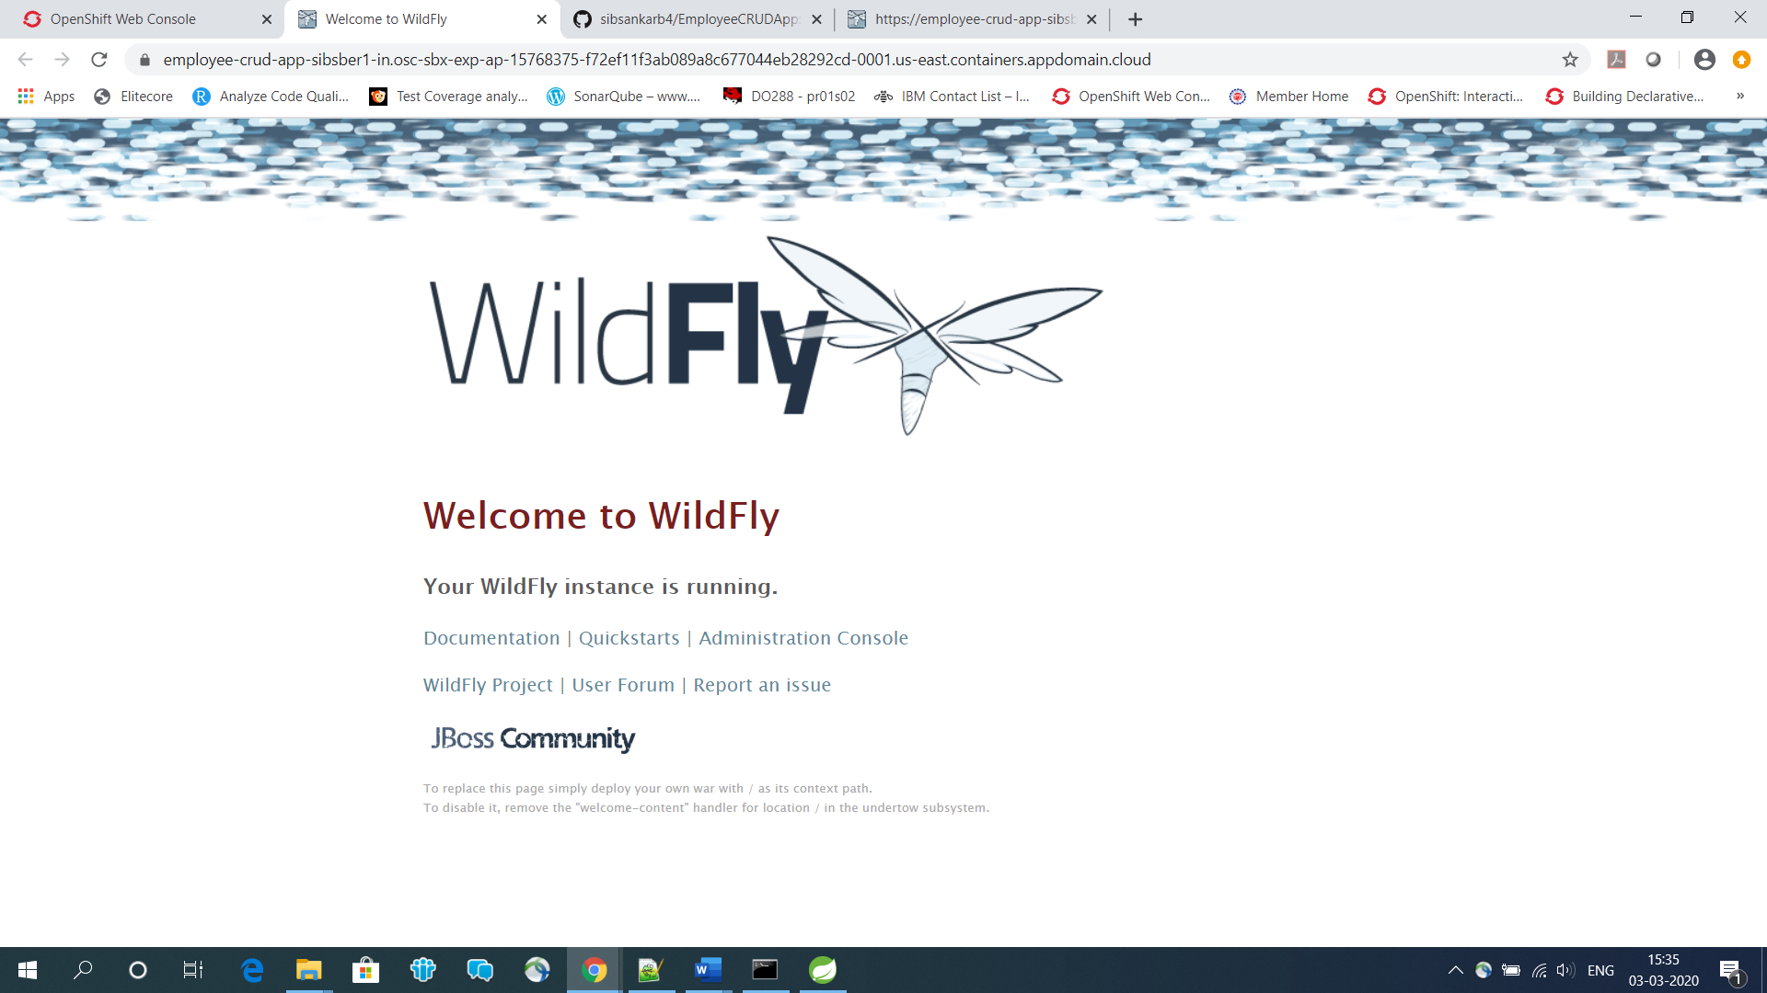

<https://employee-crud-app-sibsber1-in.osc-sbx-exp-ap-15768375-f72ef11f3ab089a8c677044eb28292cd-0001.us-east.containers.appdomain.cloud/EmployeeCRUDApp-v1/emp/info>

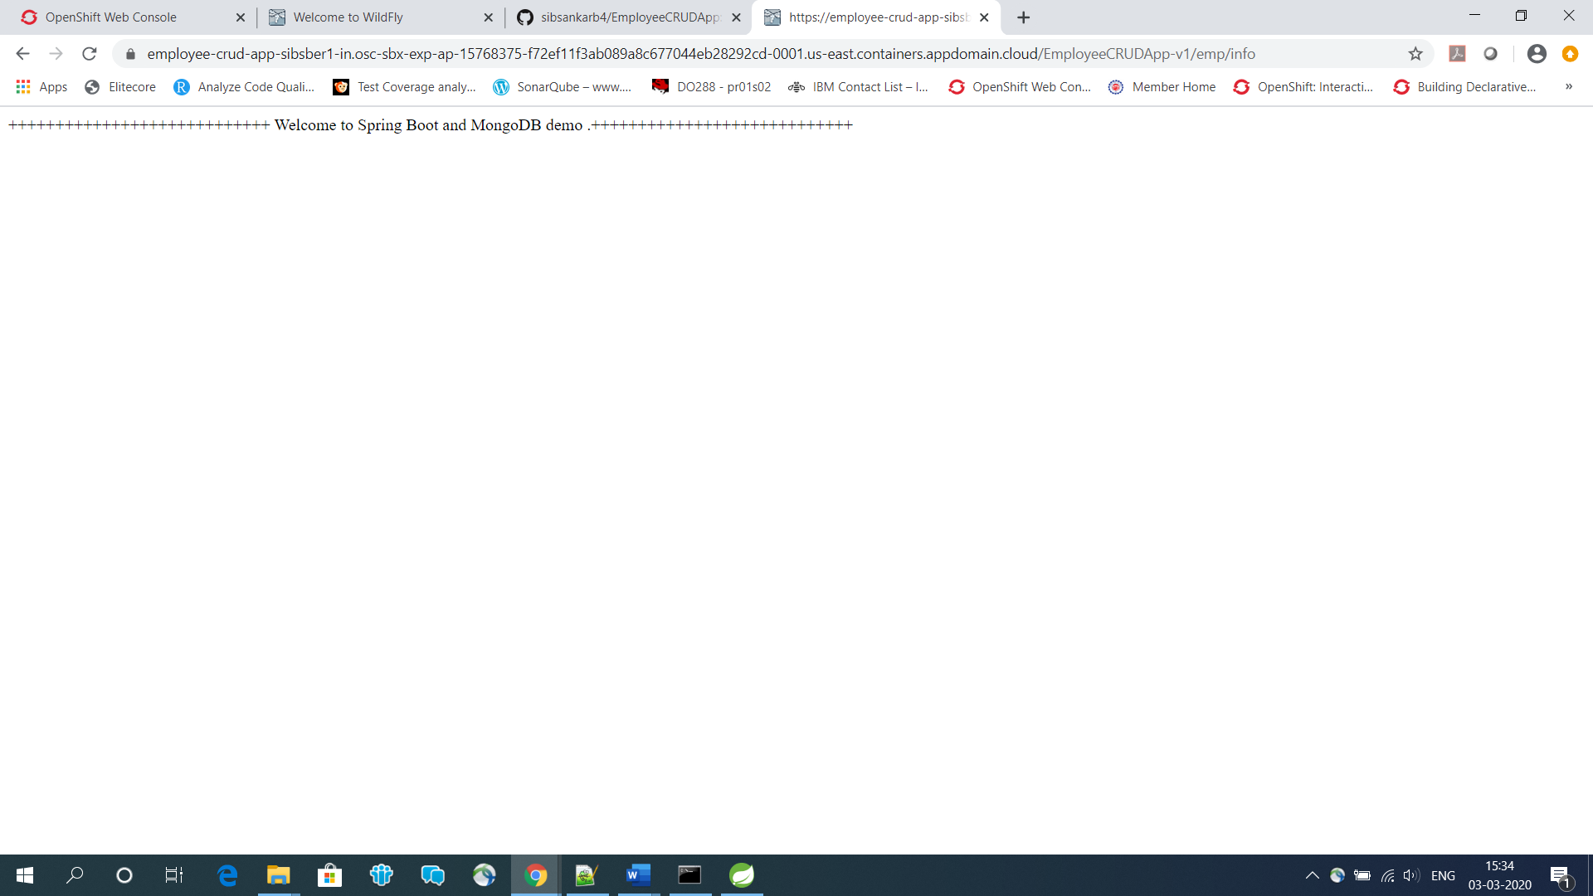

https://employee-crud-app-sibsber1-in.osc-sbx-exp-ap-15768375-f72ef11f3ab089a8c677044eb28292cd-0001.us-east.containers.appdomain.cloud/EmployeeCRUDApp-v1/emp/create

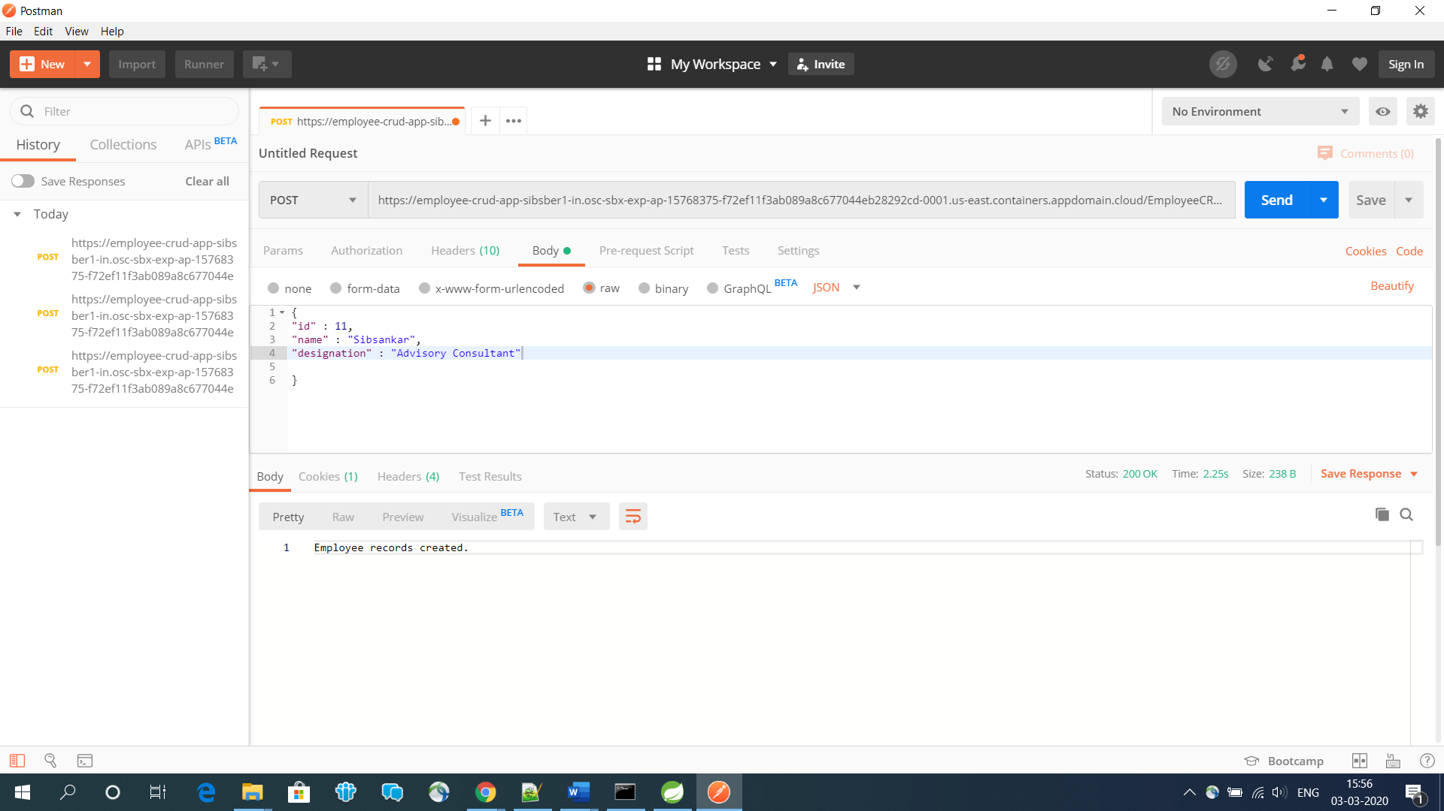

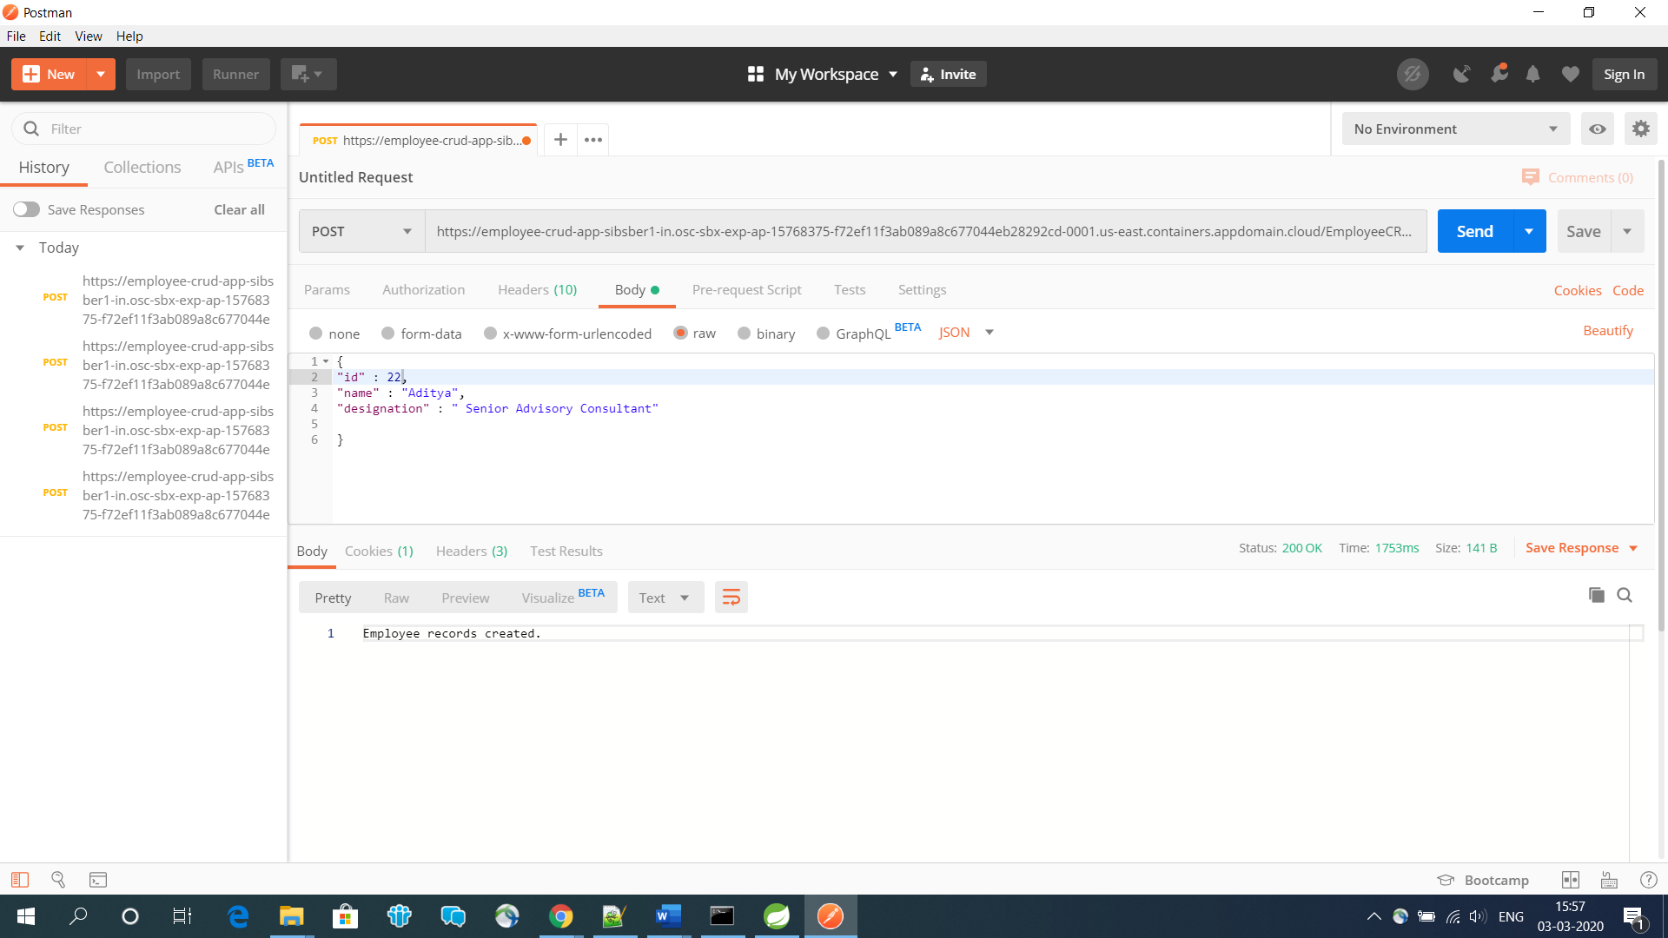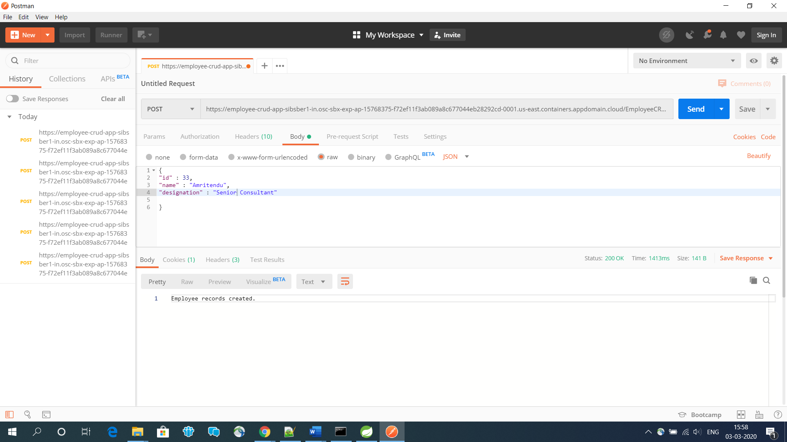

<https://employee-crud-app-sibsber1-in.osc-sbx-exp-ap-15768375-f72ef11f3ab089a8c677044eb28292cd-0001.us-east.containers.appdomain.cloud/EmployeeCRUDApp-v1/emp/getbyid/11>

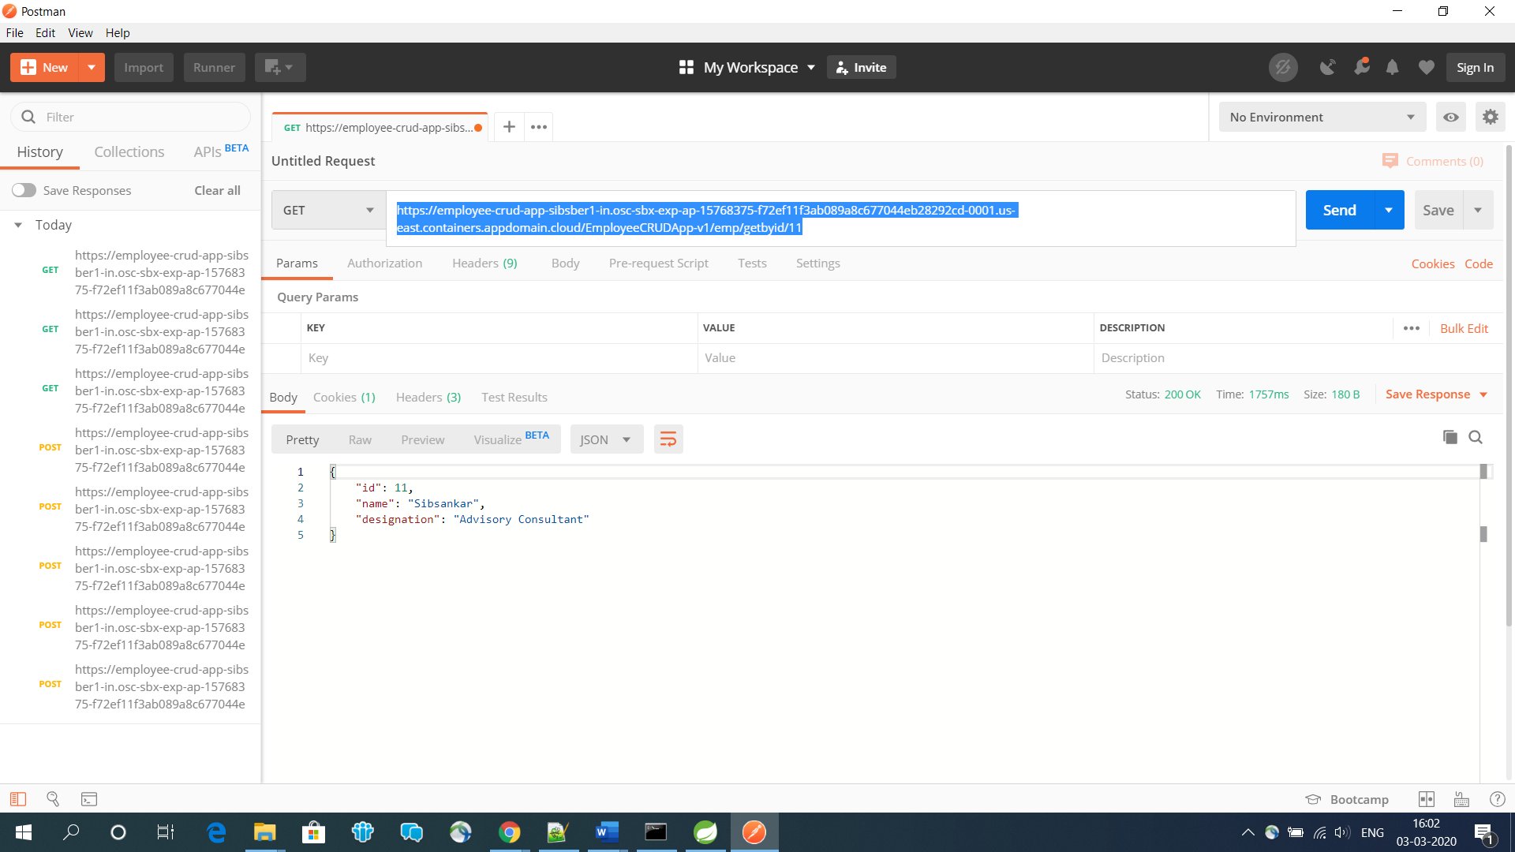

<https://employee-crud-app-sibsber1-in.osc-sbx-exp-ap-15768375-f72ef11f3ab089a8c677044eb28292cd-0001.us-east.containers.appdomain.cloud/EmployeeCRUDApp-v1/emp/update/11>

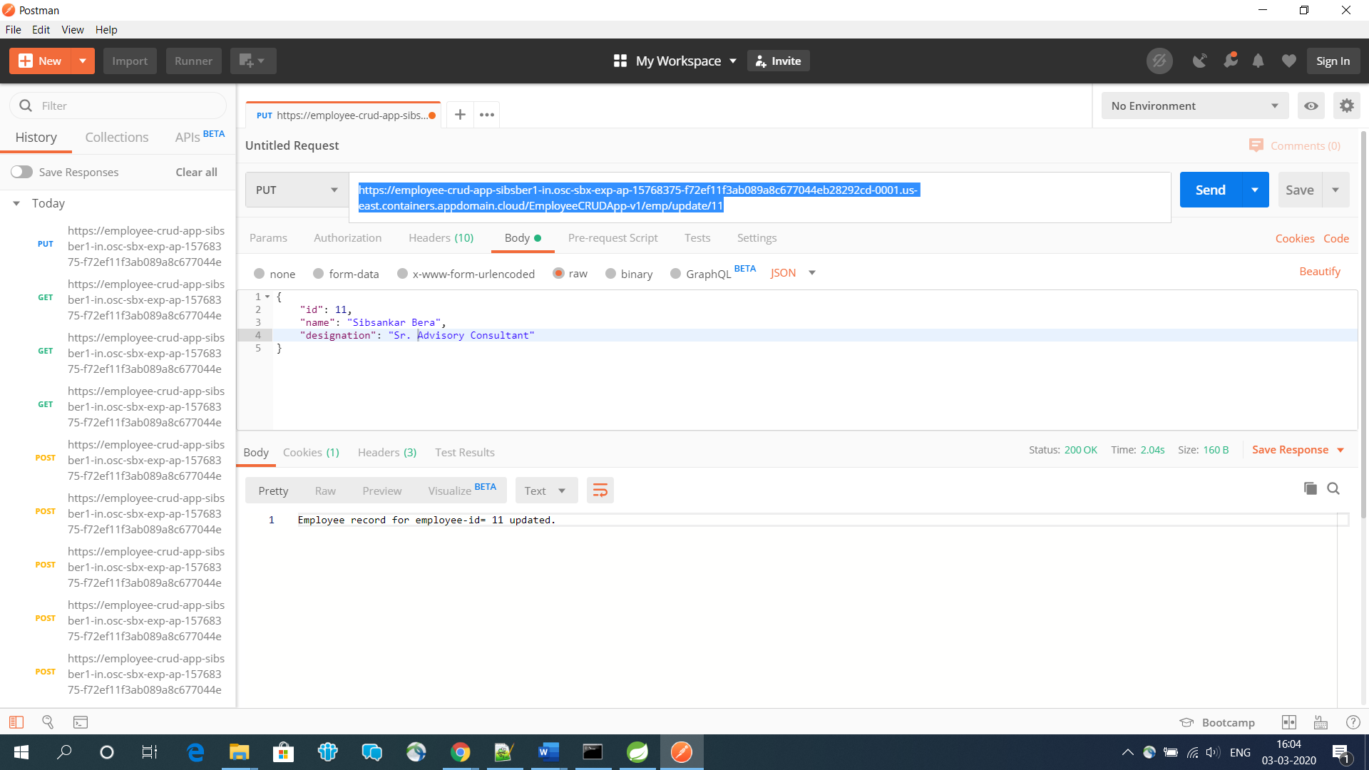

<https://employee-crud-app-sibsber1-in.osc-sbx-exp-ap-15768375-f72ef11f3ab089a8c677044eb28292cd-0001.us-east.containers.appdomain.cloud/EmployeeCRUDApp-v1/emp/getbyid/11>

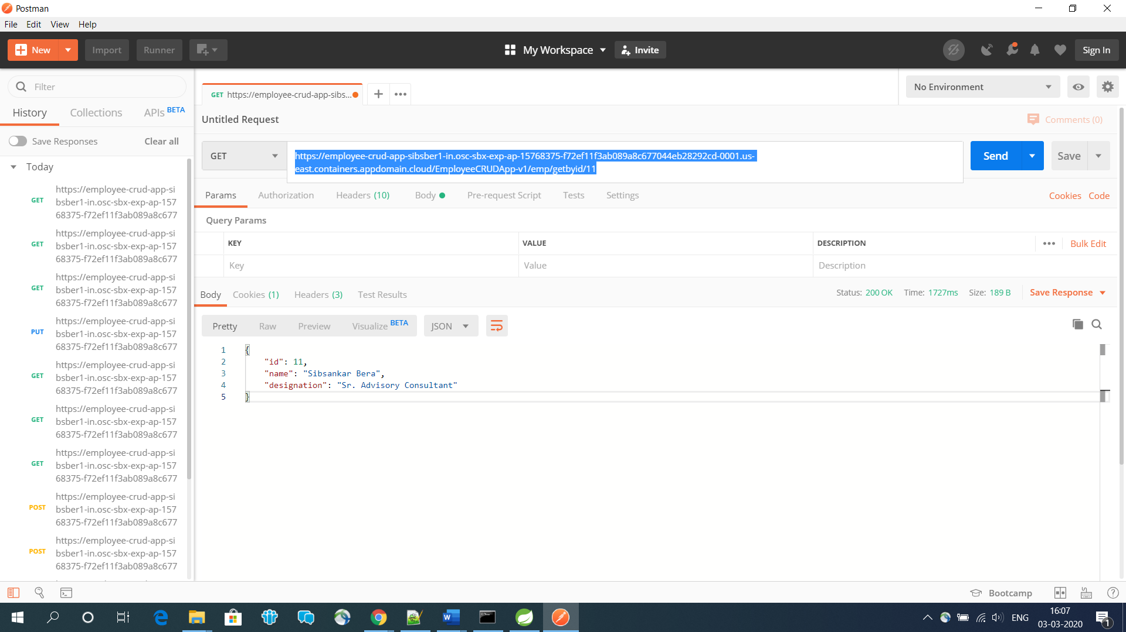

<https://employee-crud-app-sibsber1-in.osc-sbx-exp-ap-15768375-f72ef11f3ab089a8c677044eb28292cd-0001.us-east.containers.appdomain.cloud/EmployeeCRUDApp-v1/emp/getbyid/33>

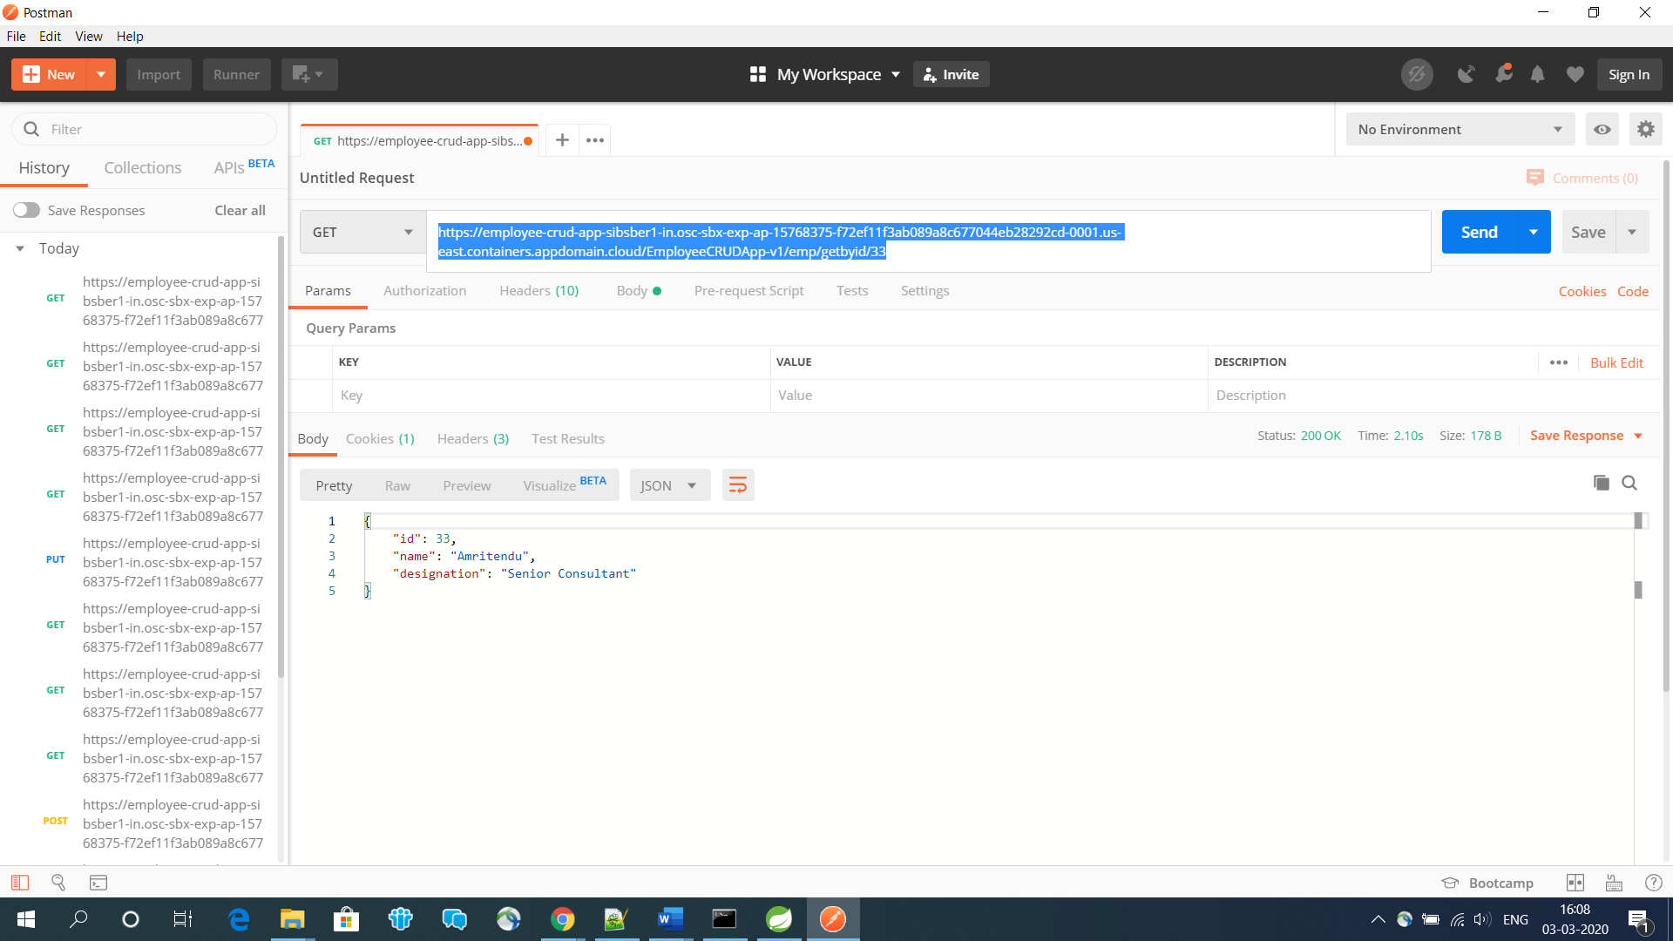

<https://employee-crud-app-sibsber1-in.osc-sbx-exp-ap-15768375-f72ef11f3ab089a8c677044eb28292cd-0001.us-east.containers.appdomain.cloud/EmployeeCRUDApp-v1/emp/delete/33>

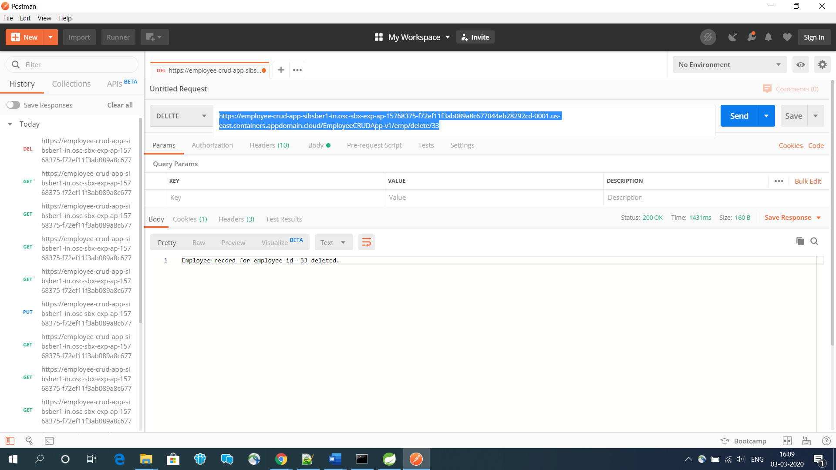

<https://employee-crud-app-sibsber1-in.osc-sbx-exp-ap-15768375-f72ef11f3ab089a8c677044eb28292cd-0001.us-east.containers.appdomain.cloud/EmployeeCRUDApp-v1/emp/getbyid/33>

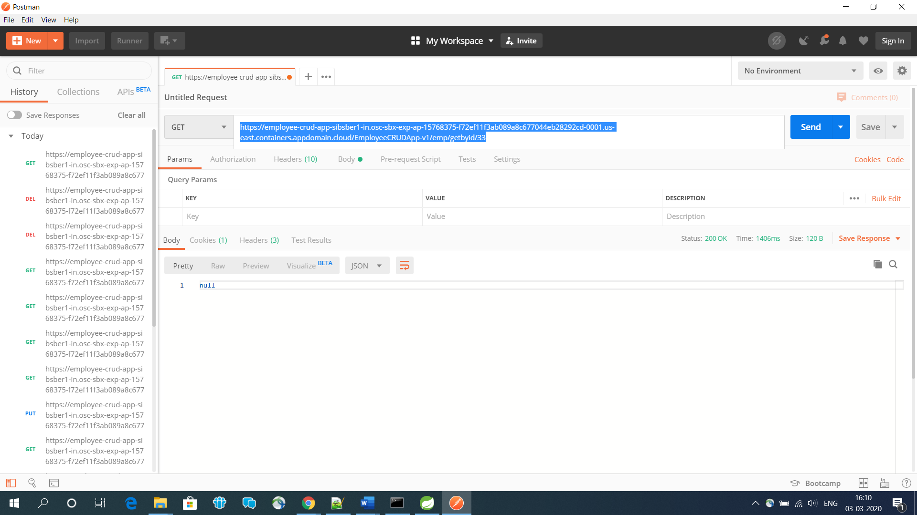

**Automatic GitHub Webhook configuration :**

Current Deployment version # 4

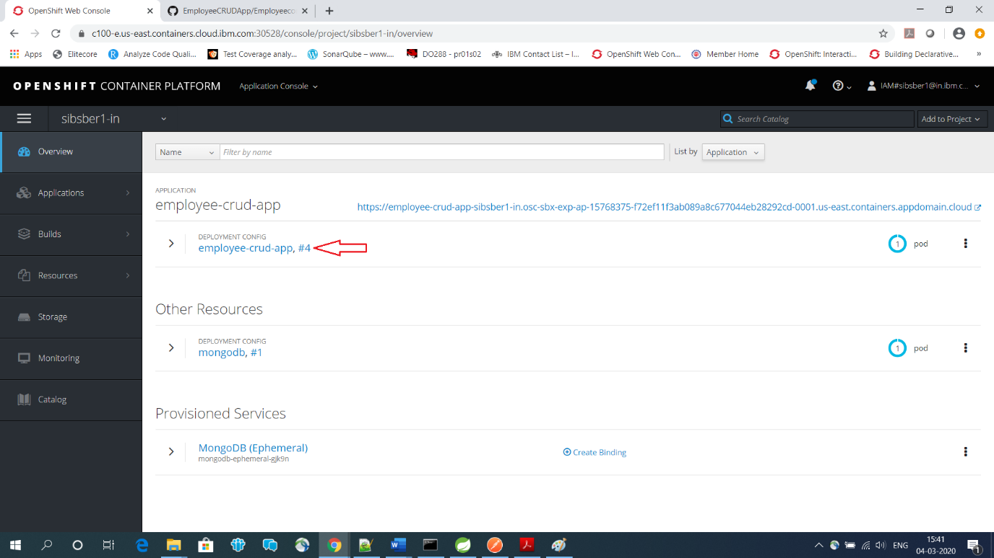

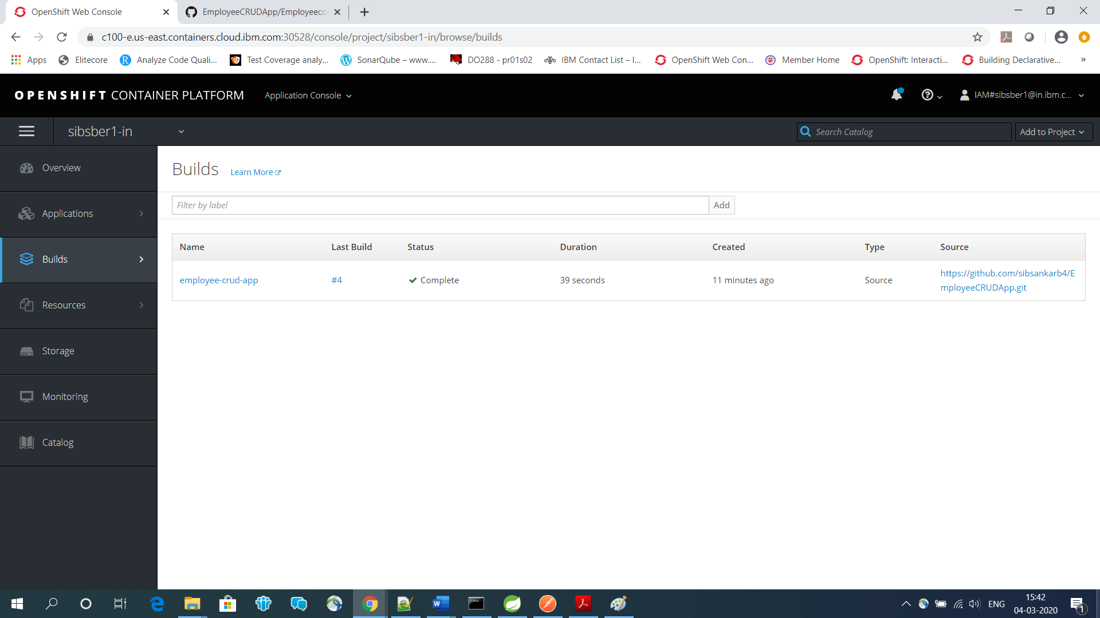

Copy the url below,

**GitHub Webhook URL:** https://c100-e.us-east.containers.cloud.ibm.com:30528/apis/build.openshift.io/v1/namespaces/sibsber1-in/buildconfigs/employee-crud-app/webhooks/0fbac458c832887f/github

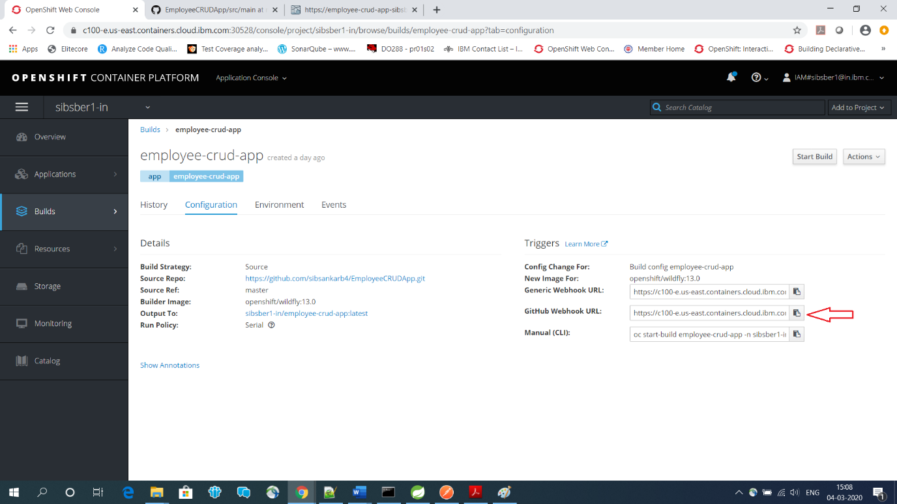

Now going to github repository.

# [sibsankarb4](https://github.com/sibsankarb4)/[EmployeeCRUDApp](https://github.com/sibsankarb4/EmployeeCRUDApp) ****>> Settings >> Webhooks****

[*https://github.com/sibsankarb4/EmployeeCRUDApp/settings/hooks*](https://github.com/sibsankarb4/EmployeeCRUDApp/settings/hooks)

Click on “Add webhook” button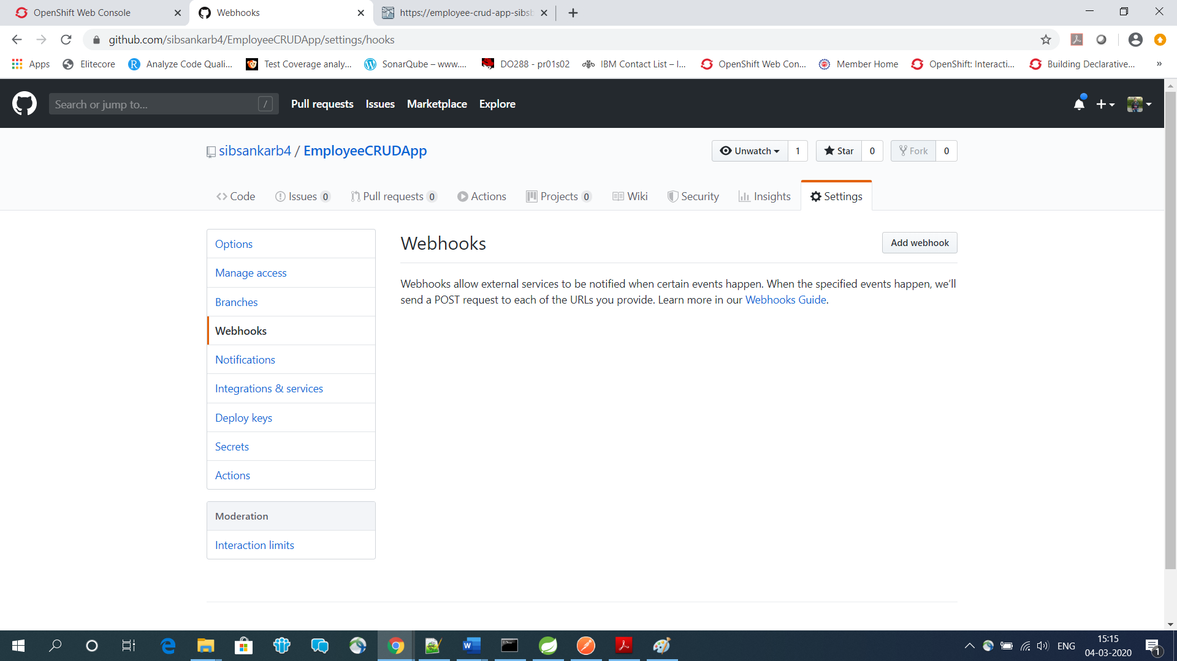

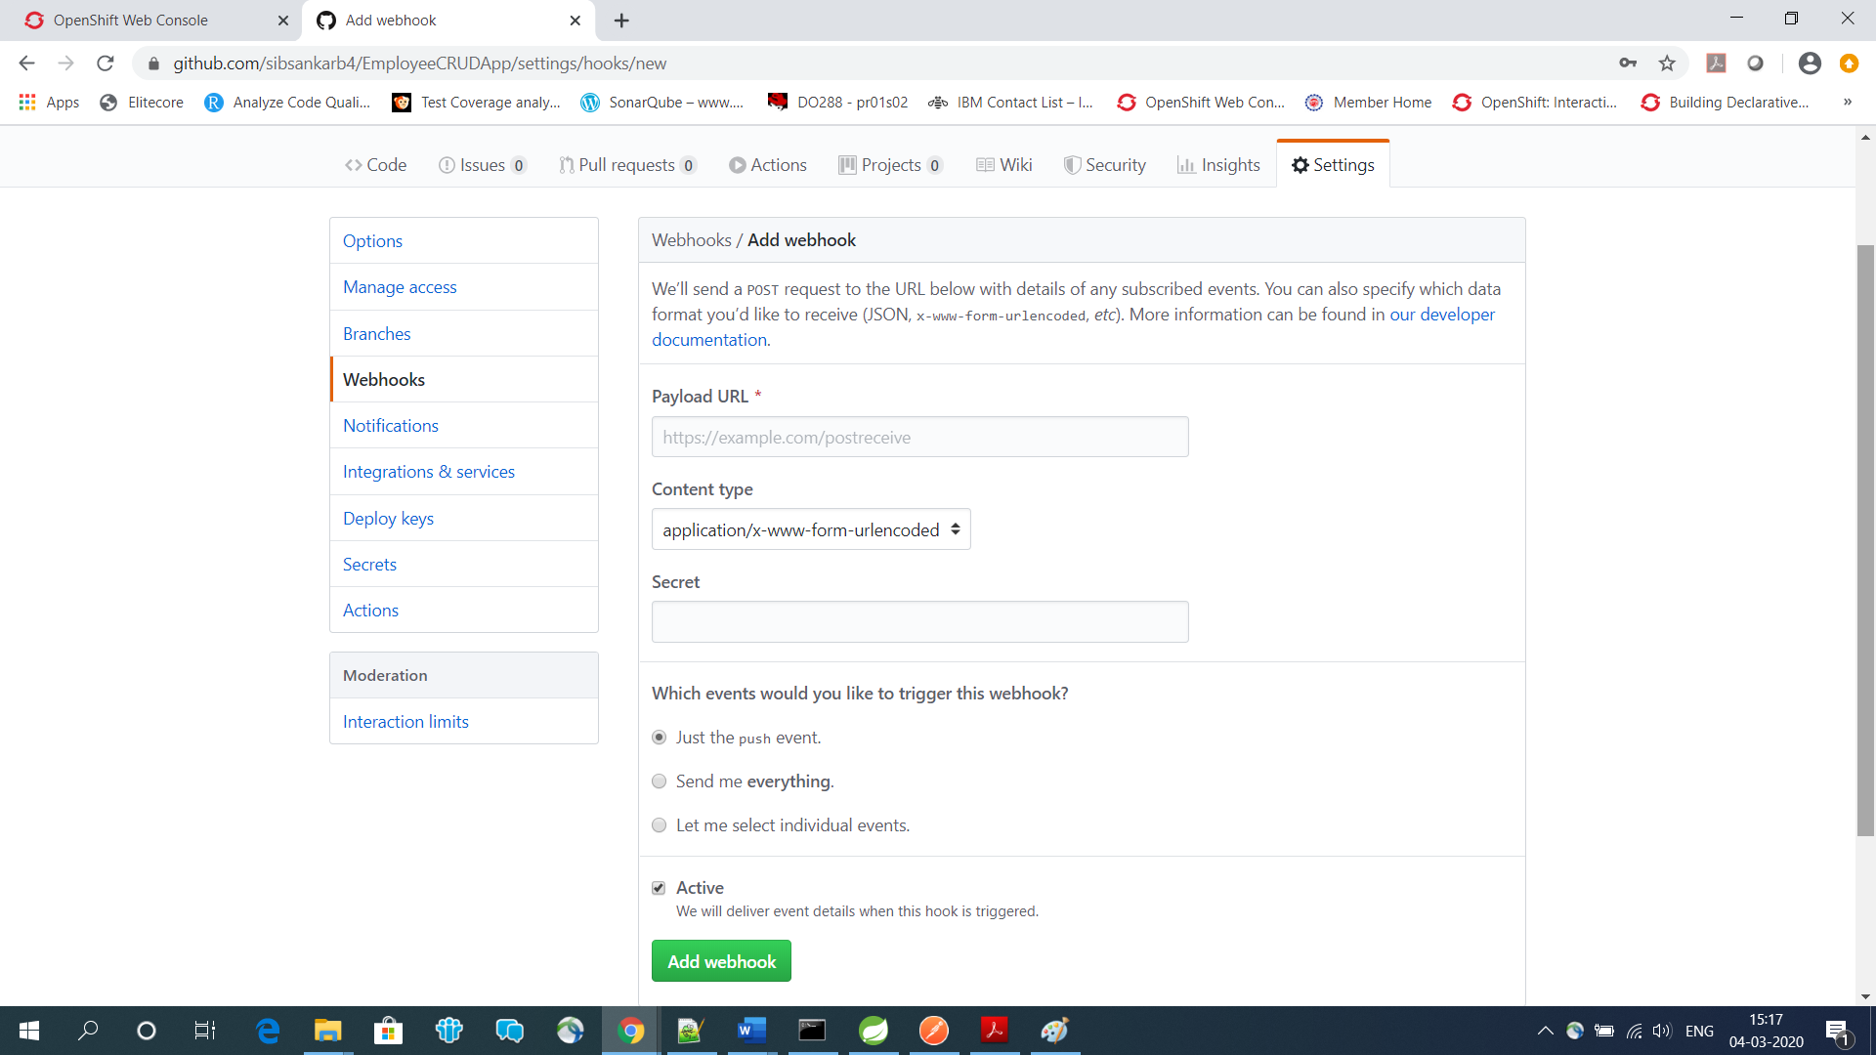

Paste the previous copied github webhook url in **Payload URL** field.

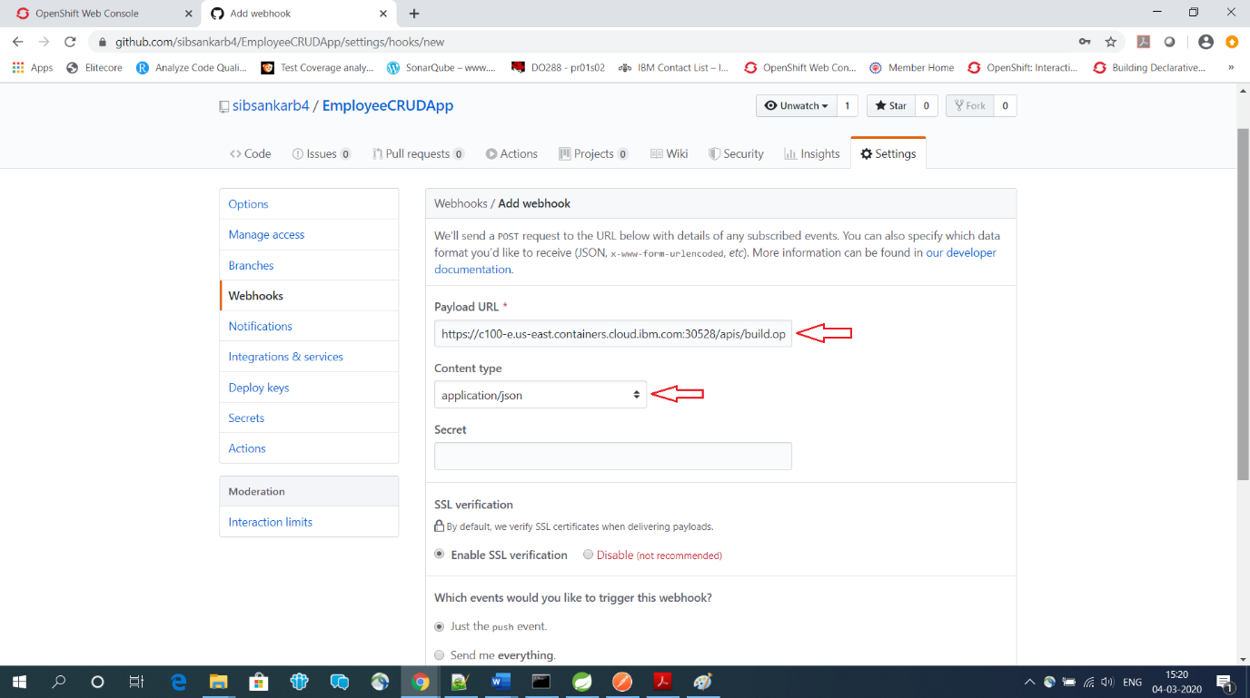

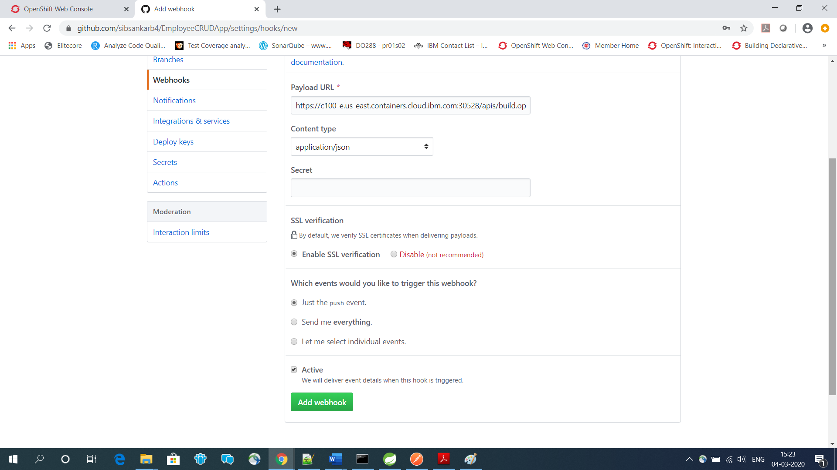

Webhook is now created successfully.

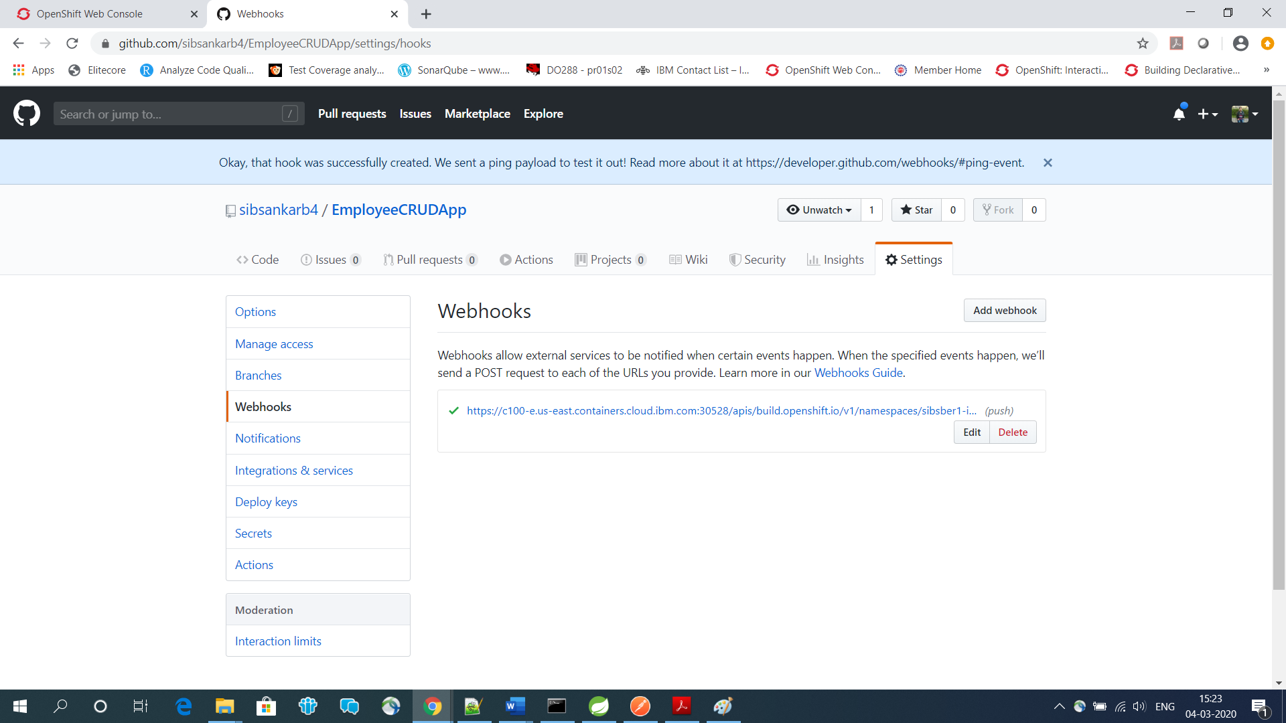

Changing some code in Employeecontroller.java and committing the same to see the automatic webhooks effect.

<https://github.com/sibsankarb4/EmployeeCRUDApp/edit/master/src/main/java/com/openshift/controller/Employeecontroller.java>

Added new message “*New Changes :::: Employee Management System ::::”*

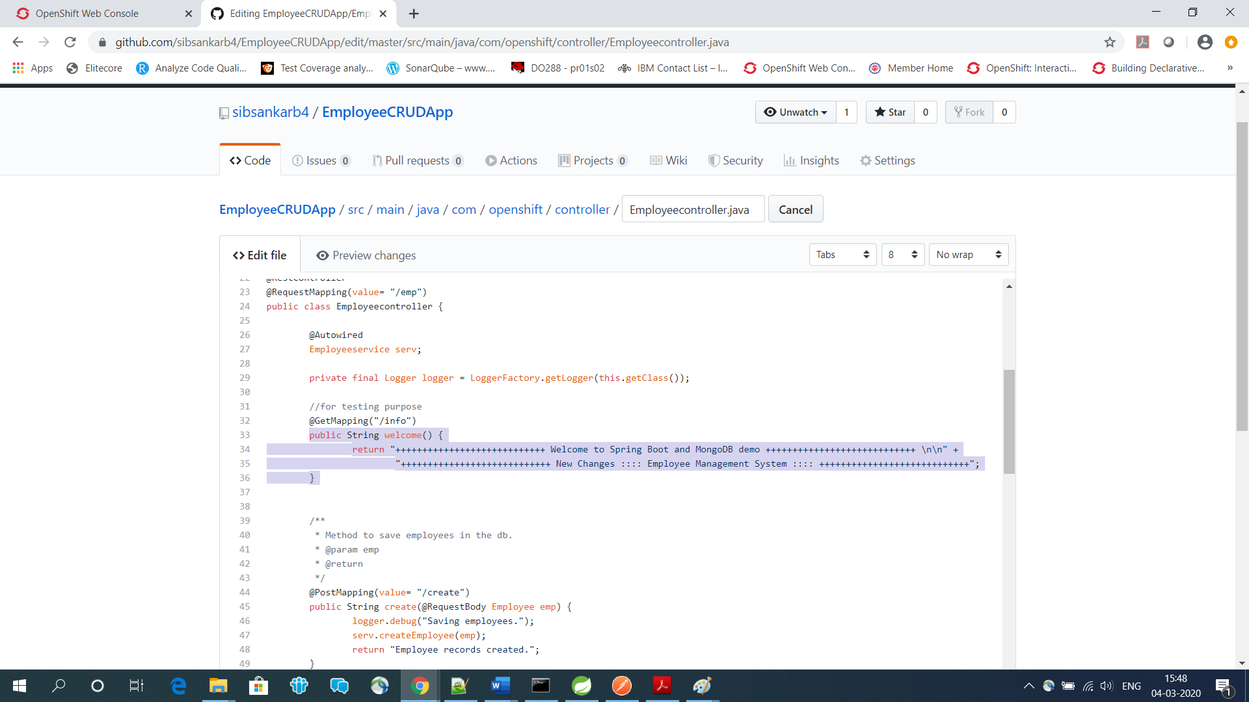

Now committing the changes.

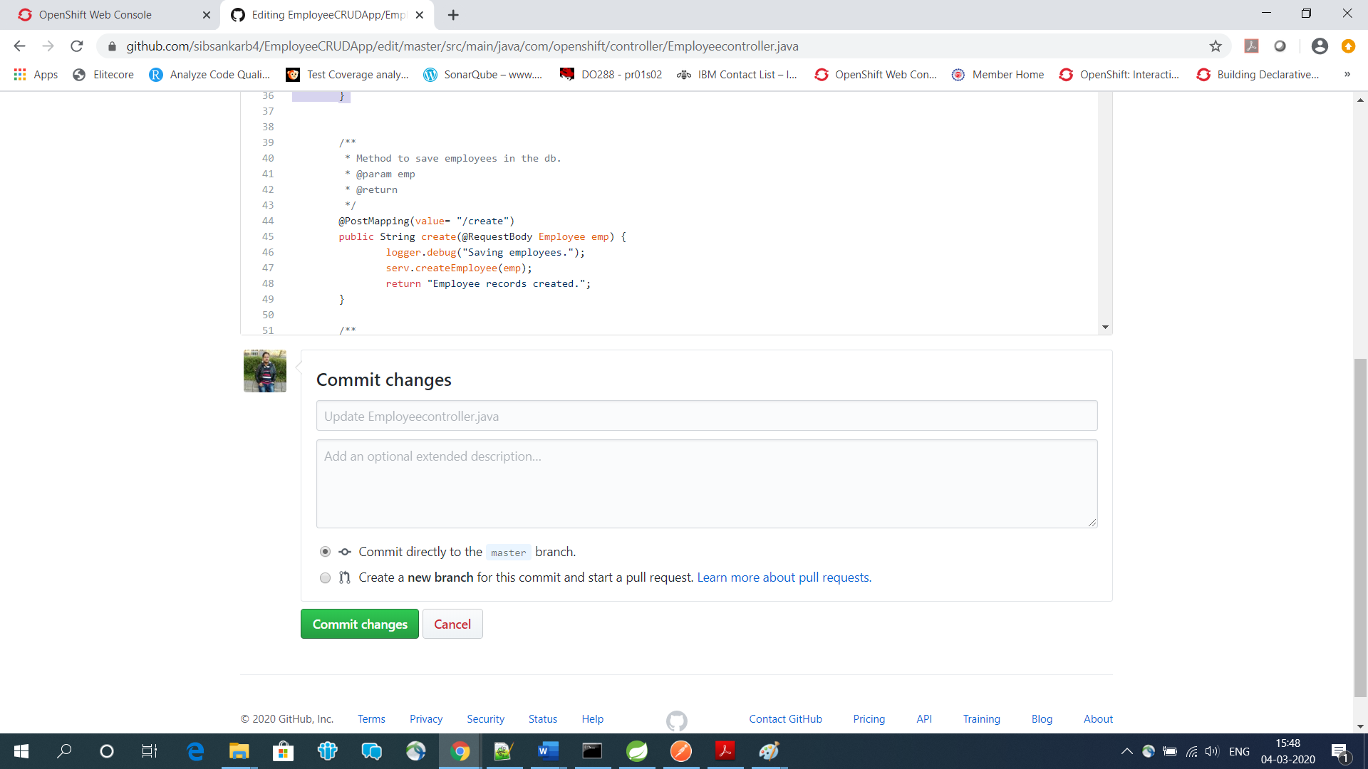

Now we can see the new deployment started automatically,

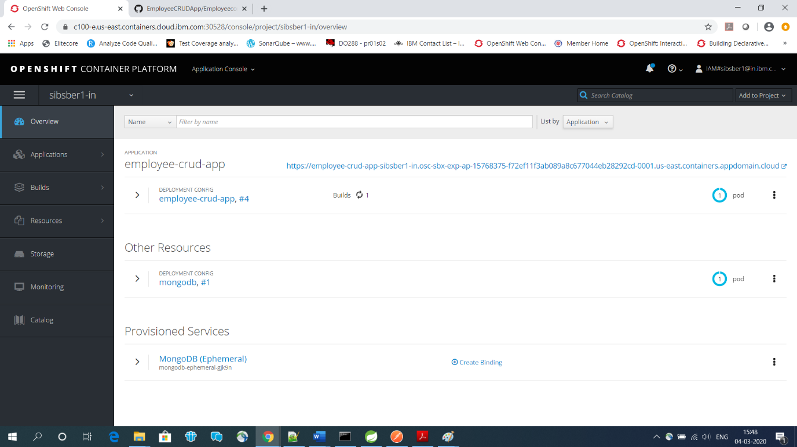

New Deployment #5

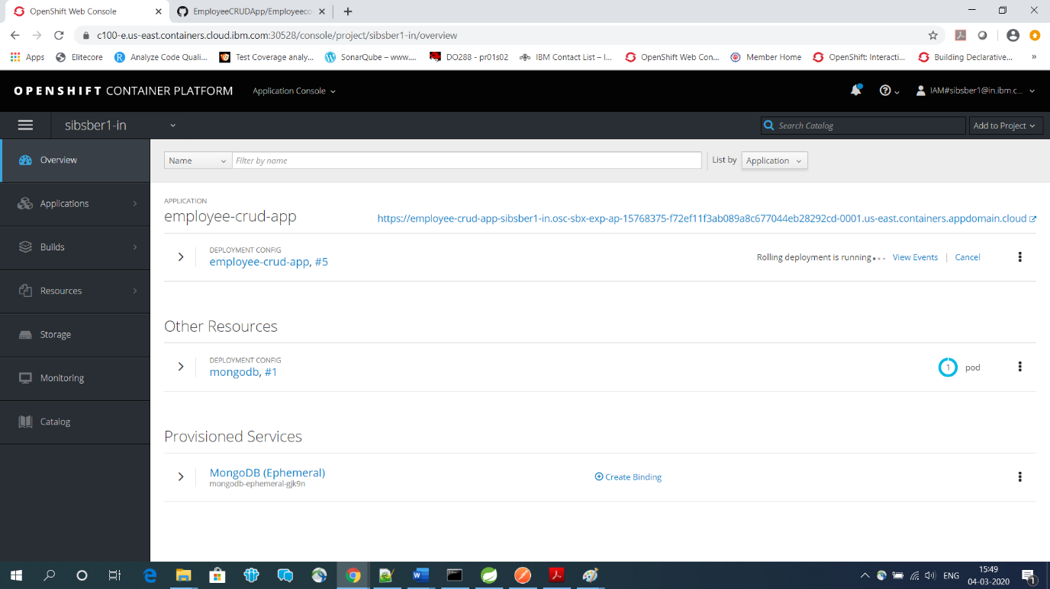

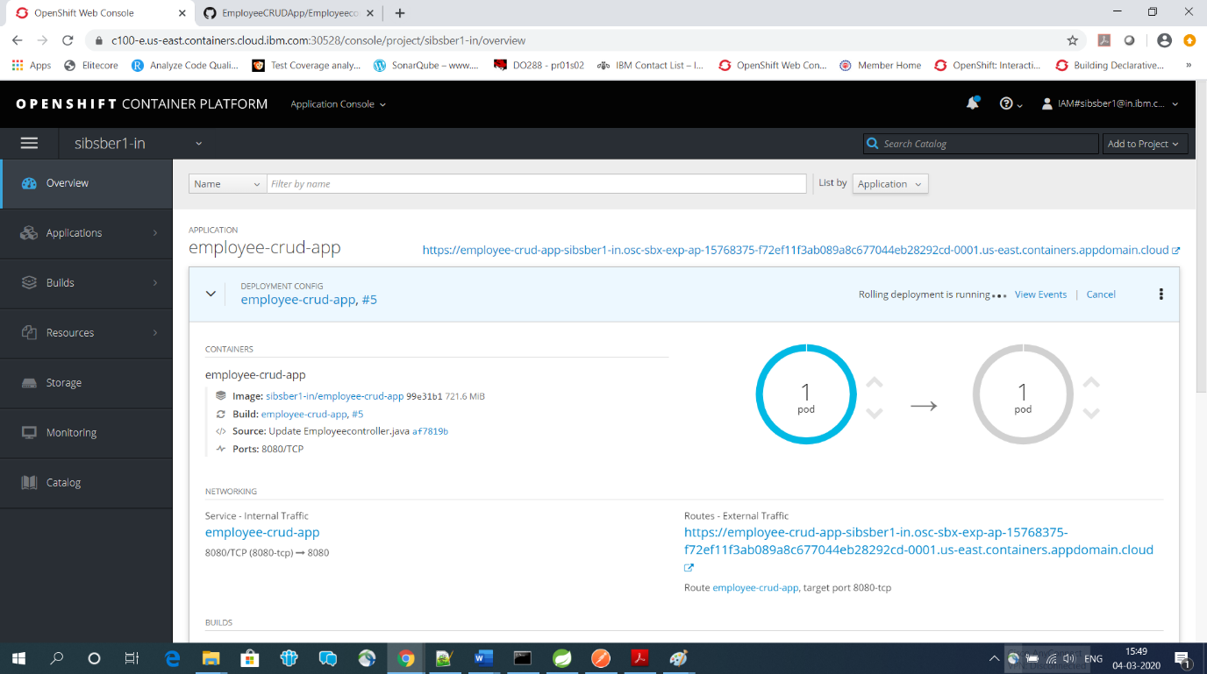

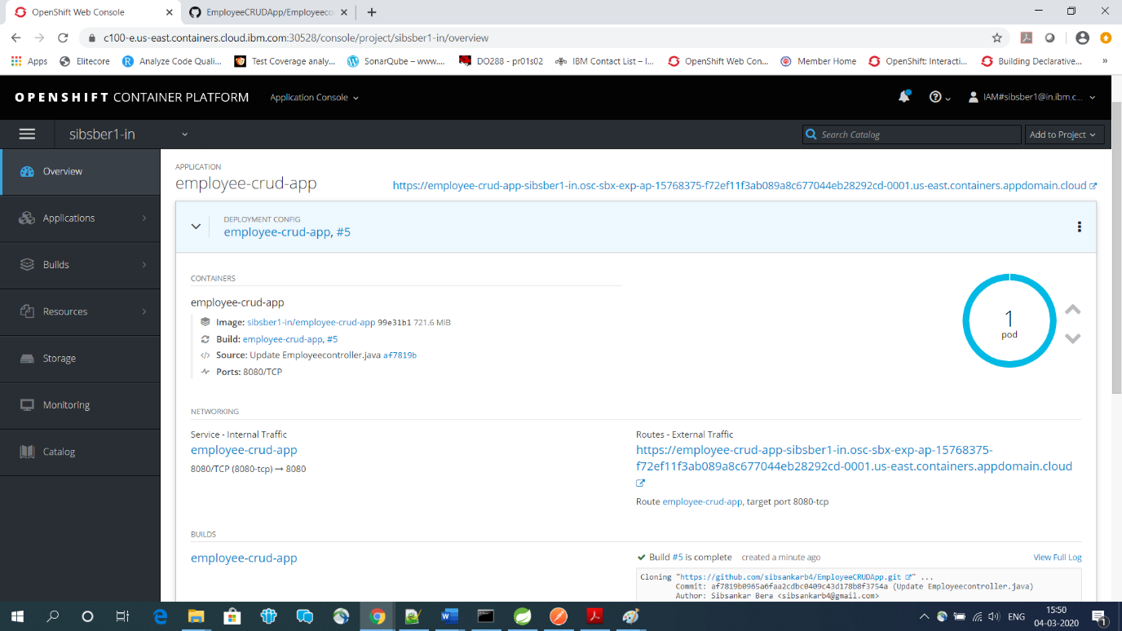

<https://employee-crud-app-sibsber1-in.osc-sbx-exp-ap-15768375-f72ef11f3ab089a8c677044eb28292cd-0001.us-east.containers.appdomain.cloud/EmployeeCRUDApp-v1/emp/info>

